**Baby-Boomers’ Investment in Social Capital:**

**Evidence from the Korean Longitudinal Study of Ageing**

**Vladimir Hlasny and Jieun Lee\***

Draft version: June 15, 2017

Existing literature has explored the role of social capital in individuals’ accumulation of human capital and other economic decisions throughout their life, and the consequences of social capital for economic or health outcomes and reported life satisfaction. Recognizing that social capital is both an input and an output of individuals’ economic choices, and that relatively little is known about capital investment and disinvestment in people’s later stages in life, we focus on a narrow question: How much investment in social capital does the Korean baby-boom generation do, and what are the determinants? In answering this question, we describe the distribution of social capital, and put figures on the degree of inequality in social capital across individuals, and across groups such as men vs. women, and urban vs. rural residents. We also investigate how accumulated social capital and decisions to invest in it differ across individuals with different household roles, such as gender, marital status and status as household head. Finally, we attempt to distinguish private, within-family, and public investments in social capital to comment on the role and effectiveness of public policy toward the elderly. We use a standard theoretical capital-accumulation model to formulate hypotheses about the cost, expected benefit, depreciation and preexisting level of social capital. We use principal component analysis to generate measures of individuals’ social network and trust in public and social institutions; linear regressions with panel-data methods to identify the determinants of social-capital accumulation among the elderly, and its implications for individuals’ life satisfaction; and finally developmental trajectory models to put emphasis on the dynamic aspects of individuals’ social-capital investment. Korean Longitudinal Study of Ageing, with four bi-annual waves of 9,000 individuals over the age of 45 each, provides necessary information on individuals’ social networks, trust, financial interactions with friends and family, life-expectancy, mental health and personality, as well as economic circumstances in which individuals live and individuals’ economic engagement. Implications for public policy toward the elderly and particularly toward one-person and female elderly households are derived.

Keywords: Social capital, return on investment, baby-boom generation, ageing.

JEL Codes: J14, E24, J26

*Ewha Womans University, Seoul, Korea. Research assistance from Ma Jihyun is gratefully acknowledged. Contact: vhlasny@ewha.ac.kr, +82 232774565, 401 Ewha-Posco Building, Ewha Womans University, Seodaemungu, Seoul 120750, Korea.

**Introduction**

Welfare and living conditions of the elderly have attracted significant attention in Korean press and by Korean policymakers in the past several years. Recent media reports about poor life satisfaction among the elderly, and the ongoing efforts to reform the country’s welfare state have brought up the issue of deteriorating physical, social and economic status of the retired population. Worldwide media have reported on an upsurge in suicides among the Korean elderly, and blamed them on inadequate social-inclusion, healthcare and pension systems. Economic status, physical health, cognitive abilities and life satisfaction of retirees have come under scrutiny by macroeconomists, healthcare professionals and welfare researchers. The World Bank (2016) has recently evaluated various implications of population ageing in Korea and other East Asian countries, and has proposed various policy responses to deal with the root causes of problems associated with an ageing society, including reforms to labor policy across the life cycle, education and continuing education policy, and welfare state. However, that report failed to mention the elderly generation’s social networks and social capital, or their isolation and exclusion from markets and society. Our study contributes by evaluating the degree and forms of elderly population’s social integration, combining several aspects of social capital into a single measurable index.

Our study also aims to contribute to literature on inequality dynamics over the life cycle (Blundell 2014), by evaluating the role of preexisting factors on social-capital accumulation, and studying the trajectory of this accumulation among different demographic groups. The subject of this study is thus important for a number of reasons. Social capital and social networks are being recognized as important factors in individuals’ economic lives, yet difficult to measure and interpret. The degree of ageing in the Korean society calls for a better understanding of the elderly generation’s lifestyle and factors that induce them to engage actively in the economy. There is scope for public policy to manage demographic change better than by increasing transfers and healthcare spending.

In what follows, we identify indicators of the stock of social capital using the size and tightness of individuals’ social networks, their family status, their participation in clubs and organizations, and their trust in public and social institutions. We identify indicators of the flow of investment in social capital using frequency of participation in social activities and communication, and monetary transactions associated with the individuals’ social networks. Principal component analysis is used to calibrate the contributions of several complementary measures of these variables, to find a reliable yet parsimonious indicator of individuals’ stock of social capital, and their investment in it in each time period. These indicators are linked to time-varying circumstances in which the elderly individuals live, in order to identify causal determinants.

**Methodology**

There is growing recognition among economists that factors beside the accumulation of hard skills and physical capital affect individuals’ economic performance and satisfaction in life. Social capital is a multidimensional attribute of each individual that interacts with their human and physical capital to produce various real lifetime outcomes. Social capital includes individuals’ soft skills such as trust in public and market institutions, sociability in particular social contexts, and size and tightness of individuals’ social networks. Different individuals accumulate different amounts and forms of social capital, and collect different economic and non-economic benefits from their investments (Astone et al. 2004). Individuals’ sociability and social networking affect their labor-market, financial and other lifetime outcomes, their welfare, as well as outcomes of their offspring (Hofferth, Boisjoly and Duncan 1998) and societal outcomes (DiPasquale and Glaeser 1999). Individuals’ norms and values they attribute to their possessions and outcomes affect their incentives to invest, as well as their life satisfaction. (Appendix 1 provides review of literature concerned with community- and individual-level social capital.)

Hence, social capital has multiple roles in individuals’ pursuit of lifetime goals. The stock and accumulation of social capital are also difficult to measure, and are like to be distributed in a complex way. The approach taken in this study thus attempts to overcome these difficulties. The empirical strategy is to outline a simple economic model of individuals’ accumulation of social capital borrowed from capital accumulation theory, and derive testable hypotheses. Next, the necessary dependent and explanatory variables are constructed. We impute measures of individuals’ time-varying stock of social capital, and their investment in social capital in each time period, and describe the distribution of these variables across individuals with different sets of background characteristics. Then we estimate regressions of these variables to test our hypotheses. Finally, we estimate regressions of individuals’ self-reported life satisfaction on the imputed stocks of accumulated social, human and physical capital to comment on the relative importance of each to this ultimate measure of individuals’ long-term achievements.

*Social capital accumulation model*

Following Glaeser (2001) and Glaeser *et al.* (2002), we adopt notation standard in the capital-investment literature, and model individuals’ choice over investment in social capital, $I_{it}^{*}$, as an argument maximizing their lifetime social-capital rents. As a departure from their model, we distinguish private and public investment in community social capital, which affects positively individuals’ private returns, and negatively private costs of social capital acquisition. We also account explicitly for individuals’ physical and human capital in their return and cost of social capital acquisition.

The average return to a unit of social capital in a time period, $R$, is thought to include both market as well as non-market streams of benefits, reflecting the property that social capital is fungible – usable in a variety of ways to achieve both market as well as non-market returns. Social capital can be used to obtain advancement on the job, new jobs (particularly in social occupations), transfers and other sources of utility (Granovetter 1974). $R$ depends on the level of the individual’s stock of social capital $S_{it}$, the stock of social capital in the individual’s community $S_{-it}$, and the individual’s human capital $H_{it}$: $R\left(S_{it},S_{-it},H_{it}\right)$. The total return to one’s social capital in a time period is thus $S_{it}R\left(S_{it},S_{-it},H_{it}\right)$. We may expect this total return to be weakly concave in own stock of social capital and weakly convex in the stock of all complementary types of capital, ${∂R}/{∂S_{it}}≤0$, ${∂R}/{∂S_{-it}}≥0$ and ${∂R}/{∂H_{it}}≥0$.

If returns to capital are diminishing as is often observed with physical capital and sometimes with human capital, particularly at high values of stocks of capital, marginal return to social capital may depend negatively on the stock of social capital. However, to the extent that social capital takes various forms, a high stock of one form of social capital (e.g., trust) may not lead to a reduction in the return to another (e.g., return to social networking).

The average outlay of time on the acquisition of a unit of social capital in a year, $C$, depends on the level of the individual’s private investment in social capital $I_{it}$, past and present investment in community social capital by the public sector, and the individual’s physical capital $K_{it}$: $C\left(I_{it},I_{-it},S_{-it},K_{it}\right)$. Availability of physical capital is thought to lower one’s cost of social-capital investment by facilitating easier access to information, substituting for time- and labor-intensive inputs and making such variable inputs more productive. Assets such as computer, car, prime housing location, and frequent-buyer status with airlines or financial companies (bestowing very-important-person privileges on a person) result in a more efficient use of search and travel time. Investment of the community or public sector in social capital – such as public support for social groups or the construction of communication and meeting-venue infrastructure – also lowers the search and travel burdens on individuals. The total cost of social capital acquisition in a time period is $w_{it}I_{it}C\left(I_{it},I_{-it},S_{-it},K_{it}\right)$ where $w_{it}$ is the marginal opportunity cost of individuals’ time. The time outlay per unit of social-capital investment, $C\left(I_{it},I_{-it},S_{-it},K_{it}\right)$, is expected to be weakly increasing in the intensity of social-capital investment, ${∂C}/{∂I_{it}}≥0$ and weakly decreasing in the availability of complementary inputs ${∂C}/{∂I_{-it}}≤0$, ${∂C}/{∂S_{-it}}≤0$, ${∂C}/{∂K_{it}}≤0$.

The stock of private social capital follows a dynamic path dependent on the individual’s social-capital depreciation rate $δ_{it}$, $S_{it}=\left(1-δ_{it}\right)S_{it-1}+I_{it-1}$. While social capital is inalienable, it is subject to depreciation for physical and mental health reasons, or if it is not maintained (Astone et al. 1999). Depreciation may also result from cross-region mobility.[1] is individual and time specific, as it accounts for the individual’s physical and mental ability to retain social networks and networking skills from year to year, and for his/her propensity to remain in the community where (s)he has invested in social capital.

In year $t$, individuals’ rents in their remaining lifetime $T_{i}-t$ from their social-capital accumulation are:

$U_{it}=\sum_{j=t}^{T_{i}}{β_{i}^{j-t}\left\{S_{ij}R\left(S_{ij},S_{-ij},H_{ij}\right)-w_{ij}I_{ij}C\left(I_{ij},I_{-ij},S_{-ij},K_{ij}\right)\right\}}$ [1]

s.t. $S_{it}=\left(1-δ_{it}\right)S_{it-1}+I_{it-1}$

This expression acknowledges that individuals discount future rents at the individual-specific factor $β_{i}$, and have an individual-specific life expectancy of $T_{i}$ in which to amortize any investments. Individuals invest in social capital in a period to maximize these remaining-lifetime rents, $I_{it}^{*}=argmax\left\{U_{it}|I_{t-1},I_{t-2},…\right\}$.

The first order condition for the maximization of rents with respect to $I_{it}$ is that the private cost of the marginal unit of social capital at time $t$ equal its private return over the individual’s remaining lifetime.[2]

[2]

The last expression, rewriting of the private lifetime return, is possible under a simplifying assumption that social-capital depreciates at a time-constant rate ($δ_{it}≡δ_{i} ∀t$).

Under the assumptions imposed on $R\left(∙\right)$ and $C\left(∙\right)$, we can thus infer signs of the expected relationships between individual’s circumstances and their choice over social-capital investment. Specifically, we can evaluate the impact of individuals’ characteristics $\left(T_{i}-t\right)$, $β_{i}$, $δ_{it}$, $w_{it}$, $S_{it}$, $H_{it}$, $K_{it}$ and community characteristics $S_{-it}$, $I_{-it}$ on their preferred $I_{it}^{*}$:

${∂I_{t}^{*}}/{∂\left(T-t\right)}>0$

$${∂I_{t}^{*}}/{∂β}>0$$

$${∂I_{t}^{*}}/{∂δ_{t}}<0$$

$${∂I_{t}^{*}}/{∂w_{t}}<0$$

${∂I_{t}^{*}}/{∂R}×{∂R}/{{∂S}_{t}}<0$ [3]

$${∂I_{t}^{*}}/{∂R}×{∂R}/{{∂H}_{t}}>0$$

$${∂I_{t}^{*}}/{∂C}×{∂C}/{{∂K}_{t}}>0$$

$${∂I_{t}^{*}}/{∂R}×{∂R}/{∂S_{-it}}+{∂I_{t}^{*}}/{∂C}×{∂C}/{∂S_{-it}}>0$$

$${∂I_{t}^{*}}/{∂C}×{∂C}/{{∂I}_{-it}}>0$$

where individual-level subscripts are omitted for simplicity. Closed-form expressions for these predictions could be obtained if we knew the functional forms of and .[3]

For instance, if we assumed the unit returns to social capital to be inverse in own social capital, and linearly increasing in the stock of complementary inputs $R\left(S_{it},S_{-it},H_{it}\right)={S_{-it}×H_{it}}/{S_{it}}$ and unit time-costs of social capital to be linearly increasing in social-capital investment and inverse in complementary inputs $C\left(I_{it},I_{-it},S_{-it},K_{it}\right)={I_{it}}/{\left(I_{-it}×S_{-it}×K_{it}\right)}$, the expression for the rents-maximizing investment is social capital at time $t$ would become:

$I_{t}=\frac{I_{-it}S_{-it}K_{t}}{2w}×\frac{β\left\{1-{\left[β\left(1-δ\right)\right]}^{T-t}\right\}}{1-β\left(1-δ\right)}×\frac{S_{-it+1}H_{t+1}}{S_{t+1}}$ [4]

Using a logarithmic transformation, the following linear empirical model could thus be estimated:

$$I_{t}=α_{1}I_{-it}+α_{2}S_{t}+α_{3}S_{-it}+α_{4}K_{t}+α_{5}H_{t}+α_{6}w+α_{7}β+α_{8}δ+α_{9}\left(T-t\right)$$

$+α_{10}β\left(T-t\right)+α_{11}δ\left(T-t\right)+α_{12}βδ\left(T-t\right)+ε_{t}$ [5]

where all variables are in logarithmic form, $α_{j}$ are the associated linear coefficients to be estimated, and $ε_{t}$ are random errors.

The predictions listed as a set of equations 3 represent hypotheses that can be tested empirically using data available in KLOSA as well as additional region-level data from public sources merged onto KLOSA. The next two sections describe, in turn, how the dependent and explanatory variables are constructed. The following section introduces the empirical model used to test the hypotheses, and discusses identification issues.

*Principal component analysis of social capital and investment in it*

To construct a single index of individuals’ social capital as a dependent variable for our analysis, we conduct static linear principal component analysis combining various observable measures of the stock of individuals’ social networks, memberships, and economic trust that individuals place in their relations and institutions. Specifically, the index of social capital is made a function of the size of individuals’ social networks; membership in church, professional organizations and clubs; their current marital status; their subjective trust in government to lead the country and provide for them in the future; their trust in economic institutions to guarantee them comfortable future; and their trust in their relatives, friends and institutions demonstrated by having outstanding loans or debts and by serving as warrantors for others’ loans (tables A2–A3 in appendix 2).

To construct an index of individuals’ investment in social capital as the second dependent variable of interest, we conduct principal component analysis of individuals’ membership in church, professional organizations and clubs; frequency of their participation in social meetings; frequency of meetings with family members and friends; frequency of phone calls; frequency of engagement in social and cultural activities; frequency of volunteering; subjective trust in government to lead the country and provide for the respondents in the future; and trust in economic institutions to guarantee them comfortable future. The resulting index of social-capital investment should be thought of as gross investment, not accounting for depreciation or loss in various ways.

The principal component analysis approach entails spectral decomposition of the correlation matrix of all observed variables, and the identification of the first principal component in the factor analysis of the observed variables. The first component can be expressed as the weighted sum of individuals’ observed variables (numbering *p* variables). When the variables are standardized by the mean and standard deviation across individuals to have zero mean and variance of one, the linear weights (*ap*) are identified as those maximizing sample variance of the index such that *Σpap2*=1:

[6]

Individual level subscripts are omitted here for clarity of presentation. Principal component analysis assigns the highest weight to variables that vary most across individuals, thus informing on maximum discrimination in social engagement between individuals.

With the first principal component identified, we compute the portion of the total variance in the observed variables that it accounts for, and the loadings of individual variables in it. Regression scores from the first principal component are used as the social-capital index for each individual in each year. By design, the estimated PCA scores are distributed around zero with unit variance, but may not be distributed normally or symmetrically, depending on the distribution of all factors included in the PCA. To facilitate interpretation vis-à-vis real-world distribution of individuals’ social capital and their investment in it, the indexes are standardized using a positive affine transformation to an interval from 0 to 100, so that relative distances between all scores would remain unchanged (even though the relative distances compared to the distance from the origin would change), and the distribution would retain its essential properties.[4] Setting the minimum to 0 is analogous to assuming that the lowest true value in the sample is zero. This is speculative for the stock of social capital, but appears plausible for gross investment in social capital, whose values cannot be negative but can be near zero for some demographic groups. In fact, studying the limited observed social engagement of individuals in the sample with $\tilde{W_{i}}=0$ suggests that the value is realistic. This normalization is important as it renders the resulting distribution of social capital stock (and investment) comparable to the distributions of income, consumption, and stocks of physical or human capital, and facilitates the comparison of inequalities in these alternative measures of economic achievement.

Normalization to the 0–100 interval also keeps relative distances between all scores unchanged, and does not affect the delineation of social-caital quantiles. This normalization aides in interpreting regression results – a 100-unit increase in the index may be interpreted as the difference between an individual in the highest percentile of social-capital endowment and an individual in the lowest percentile. A one-point increase may be interpreted as a gross increase in the stock of social capital by one percentage point of the range observed between the lowest-endowed and the most endowed individuals.

In the regression analysis using logarithm of social-capital investment index as the dependent variable, values from 0 to 1 are reset to 1, to get a logarithmic value of 0. This transformation has a negligible effect on results of regressions estimated at the means of variables (OLS), or at any but the lowest quantiles of variables. The overall method – consisting of principal component analysis, regression scoring and normalization – has the advantage of making the resulting index robust to differences in units and distributions across variables used in the analysis.[5]

*Explanatory variables*

The capital accumulation model introduced in equations 1–5 calls for the use of several sets of explanatory variables. For the typical investment in social capital in the individual’s community, $I_{-it}$, we use the mean score of social-capital investment among the individual’s peer group in that year – people in the same region, sex, and ten-year age group. For the public provision of infrastructure conducive to social capital investment in the individual’s community, $S_{-it}$, we evaluate the number of churches, clinics, elderly facilities and public health centers per capita, and share of population over 45 years of age in the individual’s province, as well as binary indicators for large cities and small towns.

The individual’s own preexisting stock of social capital, $S_{t}$, is imputed using the score from principal component analysis. In all but the first year, this variable is lagged by one year out of concern that empirical measurement issues may induce endogeneity. The individual’s stock of physical capital, $K_{t}$– affecting investment costs $C_{t}$ as well as possibly expected returns $R_{t}$– is measured using the individual’s ownership of assets, car and residence. Value of assets and home is used in monetary terms. Human capital $H_{t}$– thought to affect expected investment returns $R_{t}$– is gauged using the individual’s level of education, basic analytical skills, objective and subjective health status, absence of physical constraints, physical shape (standing for both nutrition and physical abilities), frequency of attendance of career development programs. For the expected length of time that the individual can benefit from his investment in social capital, $\left(T_{i}-t\right)$– also effectively influencing the expected $R_{t}$– age and expected time to retirement are used.

Other explanatory variables of interest are measured less precisely due to poor data availability. Beside depending on human capital, $R_{t}$ is made a function of individuals’ employment status, status as self-employed or employed full-time in family-business, status as part-time employed, and self-reported suffering from depression (non-inhibited by medication). Indeed, these could arguably be included among the components of human capital, but they share features with economic outcomes rather than merely inputs or intermediate outcomes, so we list them separately. Marginal opportunity cost of time, $w_{t}$, is measured using only annual household income, because monthly and per-capita incomes are not available for most respondents. Time discount factor $β_{t}$ (time varying, because it is available) is approximated by the degree of respondents’ myopia: their reported willingness to use a hypothetical monetary gift for leisure activities today rather than for savings or for a donation to public causes. Depreciation rate of one’s social capital, $δ_{t}$, is proxied for by respondents’ ability to recall detailed information in a quiz, and binary indicator for house ownership – making one less likely to move and more likely to invest in locality-specific social networks. As per equation 5, interaction terms of the indicators of myopia and recall ability with age ($β\left(T-t\right)$, $δ\left(T-t\right)$, $βδ\left(T-t\right)$) are added.

Finally, one’s sex, volume of personal debt, satisfaction with one’s economic status, frequency of travel, and frequency of exercise are used to account for one’s credit constraints, tastes and shadow costs of investment, and latent determinants of the return to investment.

*Estimation, and identification issues*

Unfortunately, empirical tests are complicated by a number of conceptual and measurement problems. One, life expectancy, stocks of physical and human capital, and residency in communities with high $I_{-it}$, $S_{-it}$ are themselves choice variables, and thus suffer from endogeneity in models of lifetime optimization. Two, correlation among variables of interest means that simple bivariate tests will not produce true partial effects of the tested variables. Three, most individual-level variables are measured at best imprecisely, and the available proxies may not have an entirely exogenous interpretation, resulting in inconsistent estimates. Four, missing variables that have bearing on $R\left(∙\right)$ and $C\left(∙\right)$, such as individuals’ tastes, expectations and circumstances, are likely systematically related to the explanatory variables of interest, rendering them endogenous. Self-selection of high-return individuals into obtaining a high stock of social capital represents an identification problem.[6]

To deal with these measurement and omitted-variables problems, a number of additional variables are controlled for. In particular, proxying for the latent expectations about the return on social capital are individuals’ employment status, stock of debt. Proxying for life expectancy are individuals’ age and physical health. Proxying for depreciation is one’s memory, and life expectancy of people in one’s social network, itself measured by one’s age. Proxying for cost of social-capital investment is density of elderly population in the individual’s province, and transportation cost. Proxying for the community stock of social capital is the availability of infrastructure including community organizations and healthcare centers in the individual’s province, and typical stock of social capital among sampled individuals in the province (excluding the individual in question). Individuals’ sex and marital status are controlled for.

**Data**

Data for the analysis come from the Korean Longitudinal Study of Aging (KLoSA). This dataset aims to catalog various health-related, economic, social and emotive aspects of the lives of elderly people. The dataset follows over 10,000 people aged 45 and older from over 6,000 families and from across the Korean society. The dataset is stratified using cluster sampling design, and representative of the underlying 45 year-old and older population.[7] The survey has been undertaken four times so far, in year 2006, 2008, 2010 and 2012. Questionnaire for the survey comprises eight sections on various aspects of the living conditions, practices and beliefs of the elderly. We use original variables from the survey where possible, but also variables imputed for missing values (Song et al. 2007).

In order to perform principal component analysis to impute the stock of social capital, we use variables informing of how often the respondents meet their peers, what type of groups they participate in and how frequently (or none), amount of money they lent/borrowed from someone, whether they have served as guarantors of debt for relatives, friends or others, whether they trust the country or public sector to assist them in their old age, their expectations over their future economic status (interpreted as trust in market institutions), and marital status. For the investment in social capital, we use variables informing of how often the respondents meet their peers, what type of group they participate in and how frequently, how frequently they meet or have contact with their children, how frequently they participate in cultural events (movies/performances/concerts/sports), time spent participating in groups or programs for hobby or for fun, how frequently they volunteer, trust in the country to assist them in their old age, and expectations over their future economic status.

In addition to information from KLoSA, variables on regional demographics and public infrastructure are collected from several public sources, including Korean Statistical Information Service (KOSIS). Table A2 in appendix 2 provides description and summary statistics for variables used in our model.

**Results**

*Principal component analysis of social capital and investment in it*

For principal component analysis of individuals’ *stock* of social capital, indicators from the following questions on the KLoSA questionnaire are used: How often you meet your close friends; What type of group you participate in and how frequently – or none (1 binary and 4 count variables); Amount of money you lent to someone; Status as currently married, Separated or widowed; and Feeling lonely in the past week.

Performing principal component analysis of the 9 variables, filling in missing variable values with cross-individual means and using cross-sectional population weights, the first principal component out of 9 explains 22.50% of the total variance in them, corresponding to an eigenvalue of 2.02 (figure 1).[8] The Kaiser-Meyer-Olkin measure of sampling adequacy, evaluating the proportion of variance among variables that are common to them, is 0.637, exceeding the critical value of 0.60 and suggesting that the selection of variables is adequate. The relatively low degree of acceptability reflects the poor availability of quality indicators on the survey, and heterogeneous composition of social capital. The Bartlett test of sphericity – determining whether the correlation matrix used for factor analysis is an identity matrix – rejects the null hypothesis of zero correlation across the variables at a high degree of confidence (Chi-square statistic 24,584 with 36 degrees of freedom, p-value 0.000), concluding that variable correlations in the sample are not simply due to sampling error, and justifying the use of the variables for factor analysis (Cureton and D’Agostino 1983). The loadings of all indicators on the first principal component – versus second principal component for illustration – are shown in figure 1. Questions about trust in public and market institutions do not appear to load too highly, suggesting that these questions reflect more respondents’ own characteristics rather than relationships with others in specific social contexts (Glaeser, Laibson, Scheinkman, and Soutter 2000).

Figure 1. Results of factor analysis of the stock of social capital

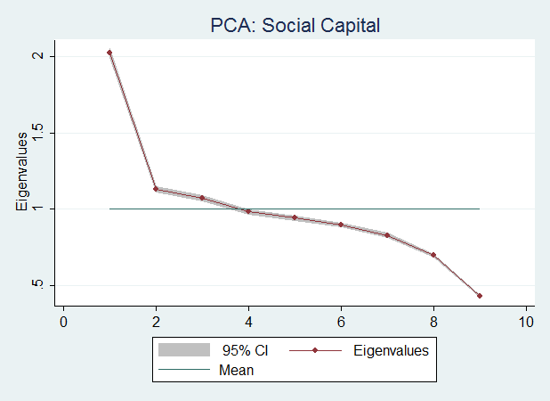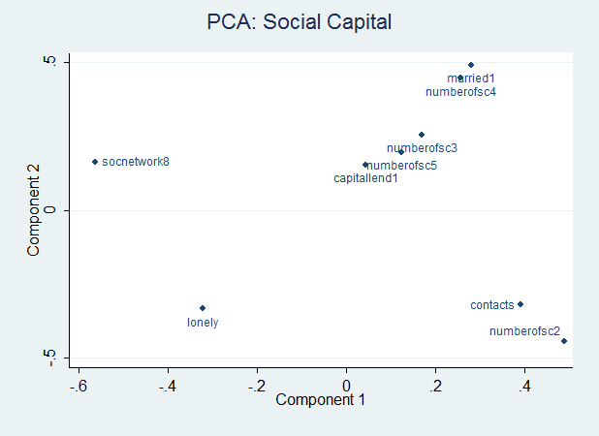

i. Scree plot of eigenvalues of each principal component ii. Variable loading in the first two princ. components

Analysis accounts for individuals’ cross-sectional sampling weights.

For principal component analysis of individuals’ *investment* in social capital, indicators from the following KLoSA questions are used: How often you meet your close friends; What type of group you participate in and how frequently (1 binary and 3 count variables); How frequently you participate in cultural events such as movies, performances, concerts or sports; Trust in the country or the public sector to assist you in your old age; and Feeling lonely in the past week.[9]

Performing principal component analysis on the 8 variables, filling in missing values with cross-individual means and using cross-sectional population weights, the first principal component out of 8 explains 20.91% of the total variance in them, and has a corresponding eigenvalue of 1.67.[10] The Kaiser-Meyer-Olkin measure of sampling adequacy is 0.646, confirming that the selection of variables is adequate. The Barlett test of sphericity rejects the null hypothesis of zero correlation across the variables (Chi-square statistic 9,292 with 28 degrees of freedom, p-value 0.000), justifying the use of factors. However, questions about trust in public and market institutions, meeting over the phone, or family meetings, do not load well, suggesting that these questions are not too informative of relationships in general (Glaeser, Laibson, Scheinkman, and Soutter 2000).

Figure 2. Results of factor analysis of the investment in social capital

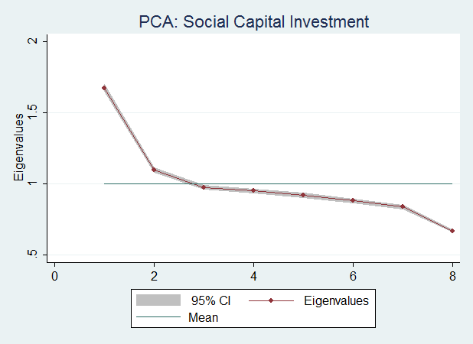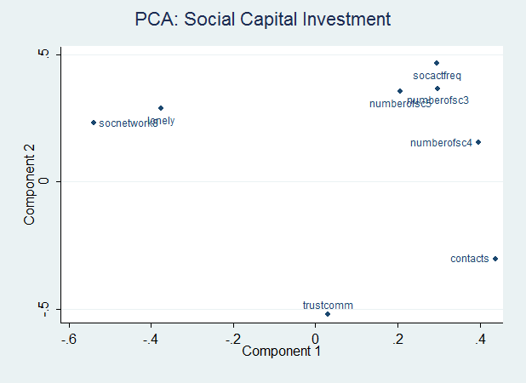

i. Scree plot of eigenvalues of each principal component ii. Variable loading in the first two princ. components

Analysis accounts for individuals’ cross-sectional sampling weights.

*Distribution of social capital and investment in it*

The estimated indexes of the stock and investment in social capital measure the relative position of any individual in the range between the least-endowed (or investing the least) and the most-endowed (investing the most) households in the population. Figure 1 presents the distribution of individuals’ imputed social capital across several notable demographic groups, and figure 2 shows the same information for the imputed investment in social capital. Both figures show that the stock and investment in social capital have long right tails, particularly investment in social capital. Sizable groups of individuals are clustered around the 15th and 30th percentiles of the scale of social capital stock, and the 5th–10th percentile as well as the bottom end of the scale of social capital investment. This suggests that few individuals accumulate numerous types of social capital intensively. Instead, most individuals acquire few types of social capital, or none at all. This is particularly clear for over-60 year-old women, among the least educated and among the poorest among the never married and divorced/separated (regardless of sex), and among non-employed, since particularly large numbers of individuals from these groups are clustered near the minimum score. At the same time, the right tail is thickest among the not-so-old, most highly educated, richest and self-employed individuals, and married men – that is, the most advantaged individuals or individuals who may hope to gain the most from social capital. Among these groups, quite a few people accumulate numerous types of social capital intensively. Interestingly, while most never-married women are trapped at the bottom end of the distributions of social capital stock and investment, a small cluster of them are at the top of the distribution of social capital investment – perhaps women leaders unburdened by family chores and overbearing inlaws.

*Kernel density estimation*

Next, recognizing that the relationships between the dependent and explanatory variables may be complex, the joint distribution of social capital and other variables is estimated nonparametrically using kernel density estimation. Imputed social capital obtained by PCA is used here. Since we have not imposed any assumptions on the probability density function of social capital, kernel density estimation allows us to observe a more realistic distribution of social capital and explanatory variables of interest. This exercise has policy implications because it identifies whether inequality in the two evaluated variables is a problem and how the inequality exhibits itself.

Kernel density estimation is a nonparametric way to obtain the probability density function of a random variable using the specific kernel function (Rosenblatt 1956; Parzen 1962). Kernel density estimator considers the distance between each observed datapoint and a specific point x and assigns weight according to the distance (Hansen 2009). Given an identically and independently distributed sample $(x_{1}, x_{2}, …, x_{n})$, we use the univariate kernel density estimator defined by

$\hat{f}(x)=\frac{1}{nh}\sum_{i=1}^{n}{k\left(\frac{x-x_{i}}{h}\right)}$ [7]

where $k\left(∙\right)$ is the nonnegative and symmetric kernel function satisfying $\int_{-∞}^{∞}{k\left(u\right)du=1}$. Since higher-order kernels have negative parts and are not probability densities, we apply the commonly used second-order Epanechnikov kernel, popular due to its efficiency properties and smoothness of the estimated density function. *h* is the positively-valued bandwidth determining the degree of smoothness.

The evaluated variables include the imputed social capital stock, imputed social capital investment, log age, log real total household annual income, and log real assets. Logarithms are used to obtain approximately Gaussian distribution in order to use Silverman’s rule-of-thumb bandwidth estimator, $h=\hat{σ}C_{v}\left(k\right)n^{-\frac{1}{2v+1}}$, where $\hat{σ}$ is the standard deviation, $ν$ is the order of the kernel, n is sample size, and $C_{v}\left(k\right)$ is a constant computed by Silverman – in case of univariate kernel density equal to 2.34. Multivariate kernel density estimation on a d-dimensional data set is obtained similarly using multiplicative kernel function defined by

$K\left(u\right)=k(u_{1})…k(u_{d})$ [8]

where k($∙$) is the univariate kernel function, and the density estimator is defined by

$\hat{f}(x)=\frac{1}{n}\sum_{i=1}^{n}{\{\prod_{j=1}^{d}{\frac{1}{h_{j}}}k\left(\frac{x_{j}-x_{ij}}{h_{j}}\right)}\}$ [9]

For rule-of-thumb bandwidth, if the joint probability density function is close to multivariate normal density, we obtain the optimal bandwidth $h_{0}=C_{v}\left(k,q\right)n^{-\frac{1}{2v+q}}$ where

$$C_{v}\left(k,q\right)=(π^{\frac{q}{2}}2^{q+v-1}{\left(v!\right)}^{2}R{\left(k\right)}^{q})/{\left(vk_{v}^{2}\left(k\right)\left(\left(2v-1\right)‼+\left(q-1\right){\left(\left(v-1\right)‼\right)}^{2}\right)\right)}^{\frac{1}{2v+q}}$$

Here the double factorial $\left(2v-1\right)‼$ represents the product of all positive odd numbers starting from *2v-1*. If all variables had unit variance, we obtain the rule-of-thumb bandwidth for the *jth* variable as $h_{j}=\hat{σ_{j}}C_{v}\left(k,q\right)n^{-\frac{1}{2v+q}}$. The numerical value of the constant $C_{v}(k,q)$ is 2.20.

The basic idea for using rule-of-thumb bandwidth is that if the true density is normal, then the computed bandwidth will be optimal and if the true density is reasonably close to normal, then the bandwidth will be close to optimal.[11] Kernel density estimation in our sample involves several steps. First, for clarity of presentation, we excluded outliers. For each variable domain, we set the maximum at the 90th percentile. Second, to get smoother density functions, we take natural logarithm of each variable except imputed social capital stock/investment to get the distribution close to normal. Imputed social capital stock/investment already show the distribution close to normal, by the design of the PCA. Values less than one were reset to unity for natural logarithm to be identified and nonnegative. Third, kernel density estimation is performed on continuous variables such as real total household annual income, age, and assets, to generate three-dimensional and two-dimensional contour maps of joint densities. Categorical variables are converted into sets of binary indicators before kernel density estimation is performed on them. Rural, small town and large city residential areas are distinguished, as are fifteen provinces. For these binary variables, two-dimensional line graphs are built. Finally, the distributions of social capital stock/investment in 2006 and in 2012 are compared.

Figures 3–8 present joint density estimates of pairs of continuous variables, followed by the corresponding contours. The red color represents the highest density while dark blue stands for the lowest density. Figure 3 shows that the lower the real annual total household income, the lower the individuals’ expected stock of social capital. Figure 4 shows the corresponding joint density estimates of income versus investment in social capital. The results are similar to those for the stock of social capital. The less income individuals have, the less they appear to invest in social capital.

Figure 3. Joint kernel density estimation of real annual household income and social capital stock

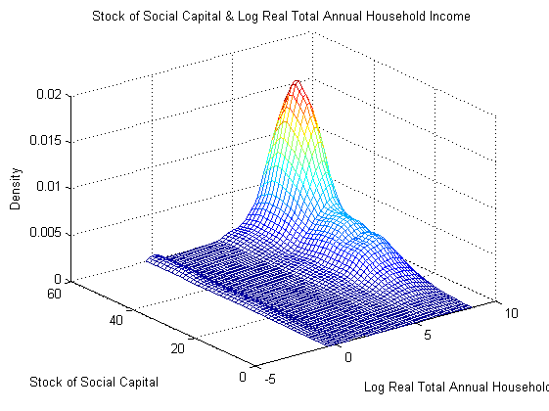 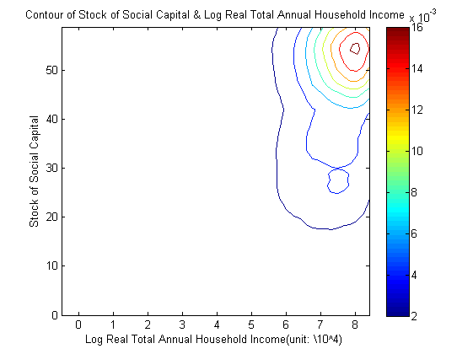

i. joint density probability function ii. contour

Figure 4. Joint kernel density estimation of household annual income and social capital investment

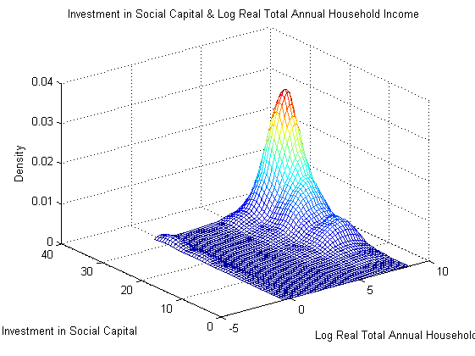 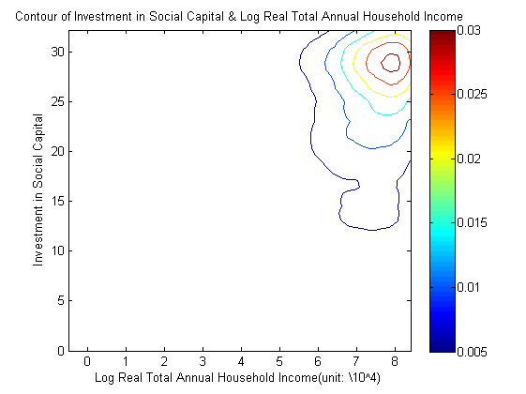

i. joint density probability function ii. contour

Figures 5 and 6 show the comparable joint density estimates of social capital stock (investment, respectively) and log valued individuals’ age. The older the individuals are, the less stock of social capital they are found to accumulate. The greatest stock of social capital has the highest density among individuals aged 50 to 55 if log value is rescaled back, a relatively young cohort in the KLoSA sample. Densities of lower stocks of social capital – around 10, 20 or 30 – increase with the individuals’ age, and are highest among 65–70 year-olds. Similar results emerge for social capital investment in figure 6. The density of relatively lower investment levels (say, score of 5) increase with individuals’ age, and are highest among 65–70 year olds. On the other hand, the density of the highest investment levels rapidly decreases as individuals age, implying dis-accumulation of social capital, through depreciation (e.g., deterioration of memory and social skills, or riddance of business engagements where social capital is useful) or loss (e.g., deaths, or moving to retirement homes).

Figure 5. Joint kernel density estimation of log valued age and stock of social capital

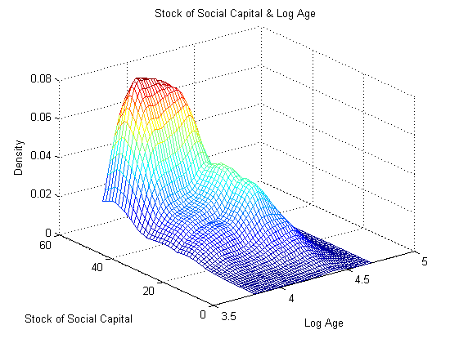 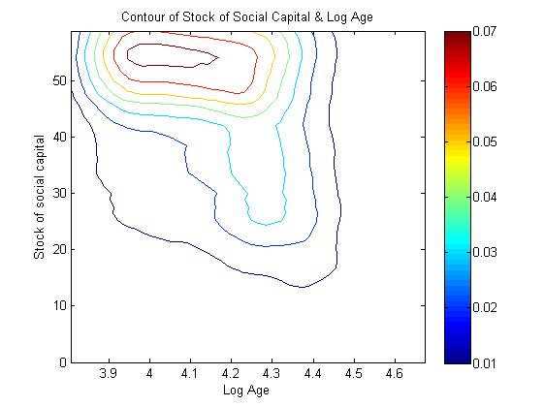

i. joint density probability function ii. contour

Figure 6. Joint kernel density estimation of log valued age and social capital investment

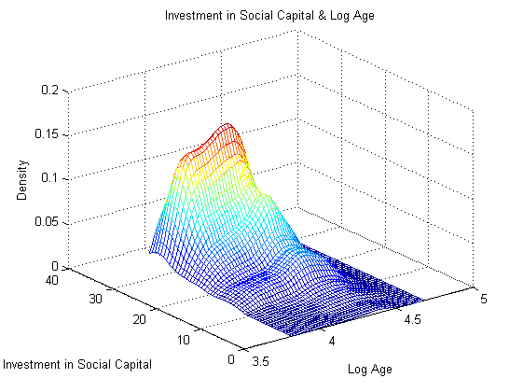 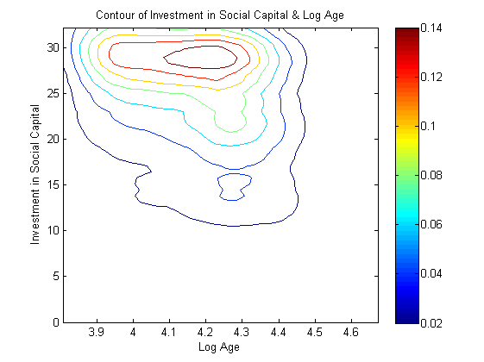

i. joint density probability function ii. contour

Figures 7 and 8 show the comparable joint density estimates of social capital stock (investment, respectively) and log valued real household assets. Figure 7 shows the expected result that the higher the real total assets, the higher the individuals’ expected social capital is. Figure 8 shows the corresponding joint density estimates of real assets versus investment in social capital. The results are similar to those for the stock of social capital. The more real assets individuals have, the more they invest in social capital.

Figure 7. Joint kernel density estimation of log valued real assets and social capital stock

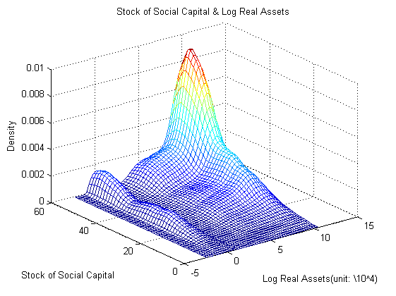 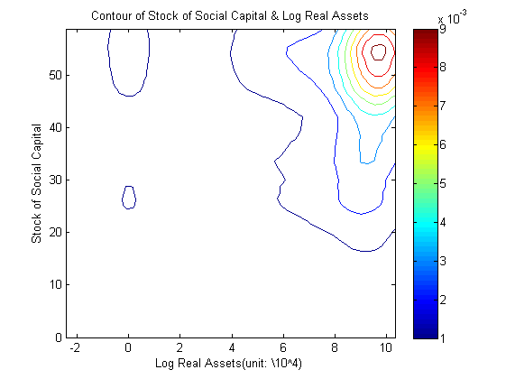

i. joint density probability function ii. contour

Figure 8. Joint kernel density estimation of log valued real assets and social capital investment

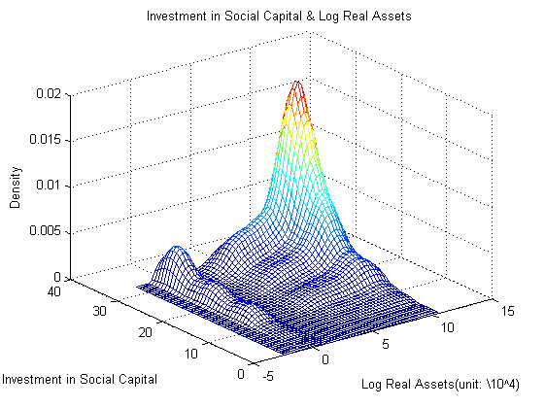 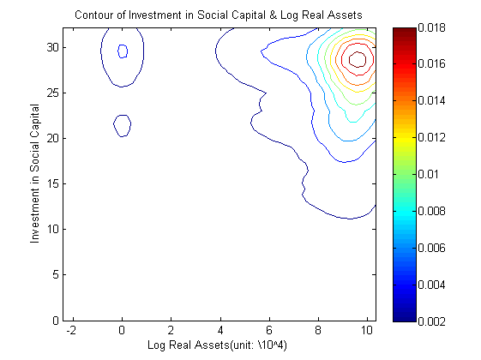

i. joint density probability function ii. contour

Figure 9. Joint kernel density estimation of social capital stock/investment in 2006 and that in 2012

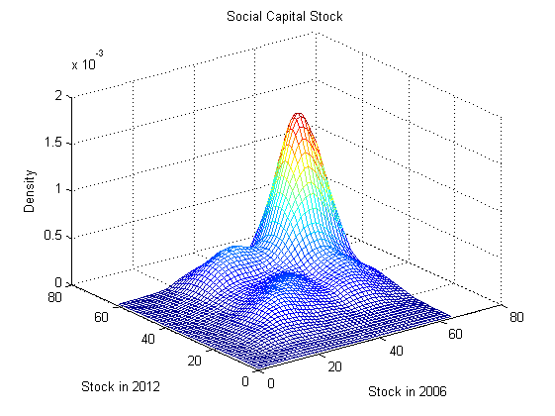 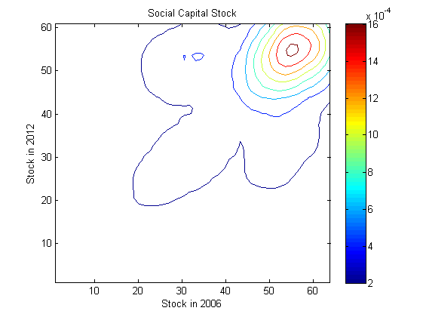

i. Social capital stock ii. contour

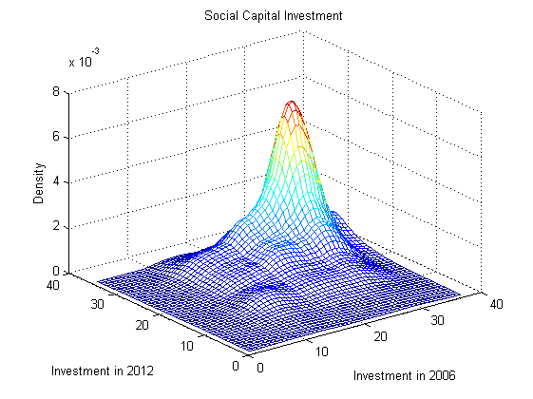 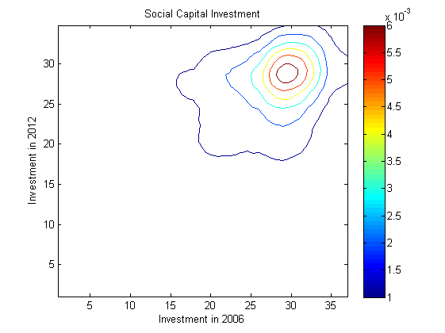

iii. Social capital investment iv. contour

Figure 10 shows univariate kernel density estimates of social capital stock and investment by region: rural, small town versus large city. Across different regions, the densities are similar, but residents of small towns appear to dominate among the top end of the distribution of social capital stock and investment, followed by residents of large cities. In the rest of the distribution of social capital stock and investment, the ranking of regions is unclear. Finally, figure 11 reports on the distribution of social capital stock and investment across individual Korean provinces. Residents of small and medium-sized towns such as Daejeon or in Gyeongbuk and Chungbuk provinces show the highest densities among the top end of the distribution of social capital stock and investment, while Jeonnam province residents show up among the low end of the distribution of social capital stock and investment.

Figure 10. Kernel density estimation of social capital by region: urban/small city/rural

i. Stock of social capital ii. Social capital investment

Figure 11. Kernel density estimation of social capital by province

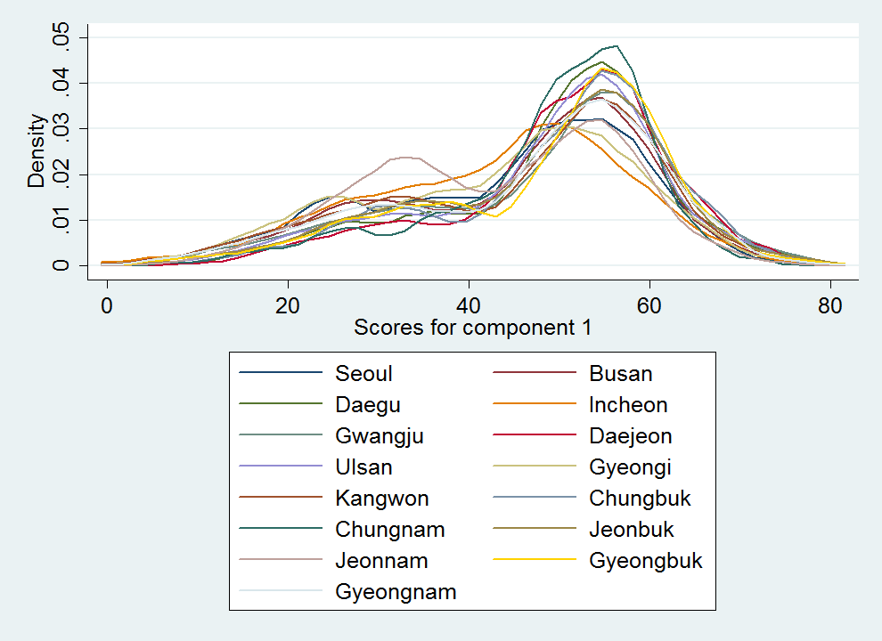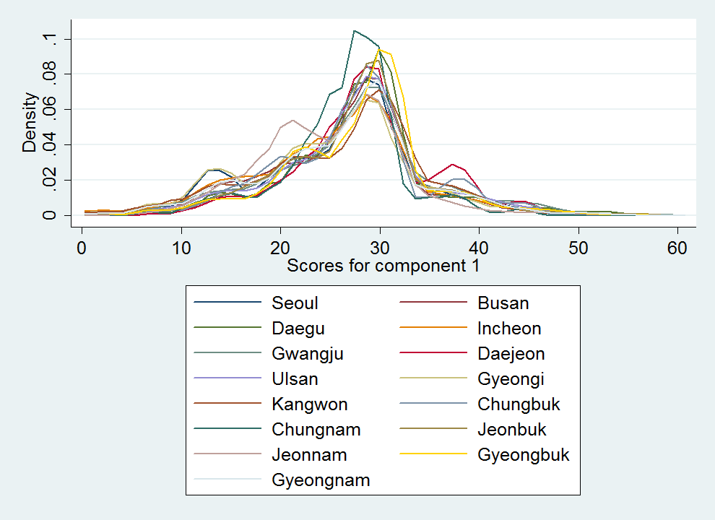

i. Stock of social capital ii. Social capital investment

*Inequality in social capital acquisition*

Next we attempt to comment on the relative degree of inequality in the entire sample as well as across demographic groups. The nature of our index of social capital constrains us in the choice of inequality measures. Shares of aggregate social-capital ownership or investment by various population quantiles may be fruitfully compared to known benchmarks, such as population income shares. This allows us to comment on the relative importance of inequality in physical versus social capital, or accumulation flows versus stock holdings. This also allows us to potentially comment on the nature of multidimensional inequality spanning income and capital flows, and stock of physical and social wealth (Heathcote et al. 2010; Smeeding and Thompson 2011; and Armour et al. 2014). This analysis is not sensitive to the central moments or the scale of the various distributions. However, in order for the social-capital versus income shares to be comparable, the distributions must start at similar real minima – such as zero. Hence, the restrictive assumption underlying table 1 is that resetting of the indexes of social-capital stock and investment distributions to start at zero agreed with the distributions of the corresponding latent true variables in our sample. Moreover, for inference to the underlying population, we implicitly assume that the true social capital of individuals in the population starts at 0 as well, just as incomes and asset ownership in the population and in our sample start at zero. As a final note, this analysis is for illustration only, as it ignores interactions of individuals’ social capital with that of others, and externalities on society.

Table 1 reveals that social capital stock and investment appear distributed far more equally than physical assets or income. The most endowed 10 percent of individuals hold on to 14–15 percent of the aggregate stock of individual-level social capital, compared to 39–42 percent of physical assets. Regarding gross accumulation of capital, the top 10 percent of individuals in terms of social-capital investment account for 16 percent of aggregate investment into individual-level social capital, compared to 23–33 percent in terms of aggregate income among the top 10 percent of earners. (This is a valid comparison. Like income, social capital investment reflects exertion of own efforts and outlays of other resources, as well market returns on those efforts and resources.)

Over time, there is no clear trend in the distribution of the stock of social capital. However, investment in social capital becomes more equal, with individuals in the middle of the distribution accounting for a larger share of aggregate investment, and individuals at the top accounting for less. Same is true for the ownership of physical assets. On the other hand, dispersion of household incomes stagnates or widens, with top-income shares increasing even as bottom-income also increase slightly.

Table A4 in the appendix shows the joint densities of quintiles of the social-capital stock and the stock of physical assets. This table is analogous to figure 7, but the densities are reported at the level of ownership quintiles, and by year. This table shows a clear positive relationships between the two distributions. Ignoring year 2006 as unreliable, we find that cells on the principal diagonal have higher densities than off-diagonal cells, particularly the top–left cell showing individuals least endowed in both. Pearson correlation of 0.24–0.26 in years 2008–2012 confirms the positive relationship between individuals’ assets and their social capital. This suggests that taking account of multiple sources of inequality across individuals – assets and social capital – yields a higher measure of inequality than when individual achievement indicators are evaluated on their own.

Similarly, table A5 shows that the joint densities of quintiles of social-capital investment and household income (analogous to figure 4) are highest for the same quintile groups on the two distributions – on the principal diagonal – and particularly for the top–left and bottom–right cells. Again, this points to multidimensional inequality as a greater concern, particularly at the extremes of the joint distribution, than one-dimensional inequality in assets or social capital.

Finally worth noting, individuals’ social capital appears resilient over time, offering little chance for intertemporal social mobility. Figure A4 in the appendix shows a strong intertemporal association between individuals’ stock of social capital in 2006 and six years later (analogous to figure 9).

Table 1. Social-capital and physical-capital ownership shares, and income shares (% of aggregate stock or income)

|  |  |  |  |  |  |  |  |  |  |  |  |  |  |  |  |  |  |
| --- | --- | --- | --- | --- | --- | --- | --- | --- | --- | --- | --- | --- | --- | --- | --- | --- | --- |
| Pop. share | 2006 | | | | 2008 | | | | 2010 | | | | 2012 | | | |  |
| S | I | Ka | w | S | I | K | w | S | I | K | w | S | I | K | w | N |
| Bottom 1% | 0.11 | 0.11 | 0.00 | 0.00 | 0.09 | 0.11 | 0.00 | 0.00 | 0.16 | 0.15 | 0.00 | 0.02 | 0.09 | 0.09 | 0.00 | 0.01 | 75-103 |
| 1–5% | 1.30 | 1.43 | 0.08 | 0.00 | 1.31 | 1.40 | 0.06 | 0.15 | 1.49 | 1.59 | 0.06 | 0.36 | 1.26 | 1.39 | 0.08 | 0.32 | 299-410 |
| 5–10% | 3.51 | 2.48 | 0.12 | 0.10 | 2.35 | 2.54 | 0.28 | 0.58 | 2.74 | 2.79 | 0.25 | 0.48 | 2.36 | 2.47 | 0.35 | 0.78 | 373-513 |
| 10–25% | 8.38 | 9.67 | 2.65 | 1.75 | 10.12 | 10.89 | 2.39 | 3.88 | 10.71 | 11.29 | 2.66 | 4.35 | 10.04 | 10.77 | 2.82 | 5.59 | 1,119-1,538 |
| 25–50% | 23.01 | 23.29 | 5.70 | 11.15 | 25.45 | 23.83 | 11.92 | 16.39 | 23.90 | 23.43 | 12.88 | 17.09 | 24.40 | 24.04 | 13.98 | 13.31 | 1,865-2,563 |
| 50–75% | 31.51 | 28.32 | 10.71 | 28.40 | 27.72 | 26.22 | 21.18 | 25.31 | 27.44 | 27.05 | 22.47 | 26.72 | 29.00 | 27.31 | 22.75 | 26.70 | 1,866-2,563 |
| 75–90% | 17.11 | 18.48 | 25.29 | 25.39 | 18.66 | 19.26 | 24.40 | 24.62 | 19.31 | 18.13 | 23.29 | 23.54 | 18.72 | 18.48 | 23.55 | 30.16 | 1,119-1,538 |
| 90–95% | 7.26 | 7.36 | 15.78 | 13.08 | 7.28 | 7.12 | 13.37 | 10.41 | 6.85 | 7.06 | 13.37 | 11.01 | 6.76 | 7.09 | 12.83 | 5.08 | 373-513 |
| 95–99% | 6.08 | 6.75 | 27.94 | 13.45 | 5.42 | 6.54 | 17.94 | 11.35 | 5.78 | 6.46 | 17.67 | 10.72 | 5.72 | 6.37 | 17.56 | 12.36 | 299-410 |
| Top 1% | 1.74 | 2.10 | 14.38 | 6.68 | 1.61 | 2.08 | 10.86 | 7.30 | 1.63 | 2.06 | 10.02 | 5.71 | 1.62 | 1.99 | 8.90 | 5.70 | 74-102 |

Note: Observations are weighted by their cross-sectional weights. Sample size *N* is reported for *S* and *I* across all years. Sample sizes for *K* and *w* are smaller.

a In 2006, only 830 respondents have non-missing data on assets, and 21 respondents (or 2.5% of sample) have assets of less than 1000. Asset-ownership shares are thus heavily dependent on individual observations and are likely to be imprecise.

*Regression analysis of investment in social capital*

Table 2 reports the results of main regressions of the investment in social capital on explanatory variables suggested by capital accumulation theory. Because of theoretical considerations in equation 1, social capital investment is used in logarithmic form. The results in table 2 confirm that the stock of social capital in the community and the amount of investment in social capital by an individual's peers are associated with higher social-capital investment by the individual. This is particularly true for the presence of churches and clinics, the density of baby-boomers in the community, and city size. However, the estimated effects on elderly facilities and public health centers are contrary to our expectations. In model specifications with fixed effects, preexisting stock of social capital is predicted to reduce further acquisition of social capital, suggesting diminishing rate of return on social capital investment.

Physical capital, as measured by assets, home value, and vehicle ownership, is associated positively with social-capital acquisition, indicating possible complementarity between the two types of capital. The effect of asset ownership is of the expected sign in the model specification with fixed effects, but weak, while the home value and vehicle are of the expected sign and significant in the model specification with OLS and random effects. The stock of human capital, similarly, has a positive effect on social-capital acquisition across most indicators of human capital (with the notable exceptions of education and physical shape), also suggesting complementarity. The effect of annual household income, proxying for the opportunity cost of one’s time, is weak but of the expected negative sign. This is different from the evidence found in prior literature (Glaeser 2001; Glaeser et al. 2002), perhaps on account of the large set of control variables included here. Individuals’ discount factor and depreciation rate – proxied for by the hypothetical spending on social activities rather than on investment or donations, ability to recall information, and a home ownership binary indicator – have unexpected coefficient signs. Perhaps, rather than standing for the lack of patience, self-reported hypothetical spending on social activities measures the taste for socio-cultural activities or is a latent indicator of one’s return to social capital investment.

Age, and time to retirement have for the most part the expected coefficient signs. Other measures of the average return to investment in social capital – self-employment in business, self-reported economic satisfaction in life and overall life satisfaction, and frequency of travel – have the expected positive coefficients. Interestingly, business employment as a full time worker does not report positive and significant result on social capital investment while that as a part time worker does. It is considered to show the elderly prefer employment for investing in social capital as “part time worker”, spending their time on other activities rather than only on work. This may indicate the preference of the elderly for part time jobs. Women are surprisingly predicted to acquire more social capital than men, perhaps from a lower starting point.

Interactive effects among individual-specific factor, time, and depreciation rate – proxied by the hypothetical spending on social activities rather than on investment or donations; desirable retirement age; ability to recall information respectively – are reported to be significant. As expected, individual-specific factor shows negative effect on investment in social capital by and large among several versions of regression model as well as variables regarding to time does. Likewise, depreciation rate almost always shows a positive effect on the investment in social capital. Finally, marital status[12] is also reported to be significant in OLS and random effects models. The result shows that married individuals are more inclined to invest in social capital than those who are not married.

The Hausman test is used to evaluate whether models with fixed effects – as consistent but possibly inefficient models – yield coefficient estimates that are statistically different from models with random effects – as efficient but possibly inconsistent models. The Hausman test for the basic model with 18 degrees of freedom (columns 1–3) yields a Chi-square statistic of 2,922; for the intermediate model with 25 degrees of freedom (columns 4–6) the Chi-square is 2,843; for the full model (columns 7–9) the Chi-square with 32 degrees of freedom is 3,048. These three statistics are significantly above zero, indicating that models with fixed effects and with random effects produce significantly different sets of coefficient estimates.[13] This is taken as evidence that differences in coefficients – due to inconsistency in random-effects models induced by omitted time-constant heterogeneity – are large even accounting for different efficiency properties of the fixed-effects and random-effects models.

Table 2. Main regression results of social capital investment

|  |  |  |  |  |  |  |  |  |  |  |
| --- | --- | --- | --- | --- | --- | --- | --- | --- | --- | --- |
| Model vars. | Indicators | OLS (1) | FE (1) | RE (1) | OLS (2) | FE (2) | RE (2) | OLS (3) | FE (3) | RE (3) |
| Log(I-i) | Log(I-i) | 0.043 | 0.263*** | 0.199*** | 0.296*** | 0.228*** | 0.354*** | 0.316*** | 0.248*** | 0.324*** |
|  | (0.064) | (0.074) | (0.063) | (0.070) | (0.075) | (0.072) | (0.069) | (0.077) | (0.071) |
| Log(St-1) | Log(S) | 0.412*** | -0.106*** | 0.234*** | 0.401*** | -0.102*** | 0.250*** | 0.412*** | -0.106*** | 0.252*** |
|  | (0.011) | (0.015) | (0.011) | (0.011) | (0.015) | (0.011) | (0.012) | (0.015) | (0.012) |
| S-i | Churches | 0.012*** | 0.011 | 0.017*** | 0.004 | 0.040 | 0.008*** | 0.004 | 0.040 | 0.008** |
|  | (0.002) | (0.023) | (0.003) | (0.003) | (0.030) | (0.003) | (0.003) | (0.030) | (0.003) |
|  | Clinics |  |  |  | -0.003 | -0.001 | -0.006 | -0.004 | 0.004 | -0.005 |
|  |  |  |  | (0.004) | (0.005) | (0.003) | (0.004) | (0.006) | (0.003) |
|  | Elderly facilities |  |  |  |  |  |  | -0.004 | -0.033*** | 0.000 |
|  |  |  |  |  |  |  | (0.003) | (0.012) | (0.003) |
|  | Health centers |  |  |  | 0.002*** | -0.003** | 0.002*** | 0.002*** | -0.003** | 0.002*** |
|  |  |  |  | (0.000) | (0.001) | (0.000) | (0.000) | (0.001) | (0.000) |
|  | Pop. 45+ | 0.502*** | 1.092** | 0.491*** | -0.110 | 1.988*** | -0.069 | -0.108 | 2.289*** | -0.089 |
|  | (0.067) | (0.429) | (0.078) | (0.111) | (0.661) | (0.122) | (0.110) | (0.646) | (0.120) |
|  | Big city |  |  |  | 0.041*** | -- | 0.052*** | 0.038*** | -- | 0.052*** |
|  |  |  |  | (0.011) |  | (0.012) | (0.011) |  | (0.012) |
|  | Small city |  |  |  | -0.026*** | -- | -0.031*** | -0.028*** | -- | -0.034*** |
|  |  |  |  | (0.007) |  | (0.008) | (0.007) |  | (0.008) |
| K | Assets |  |  |  | -0.002 | 0.006 | 0.002 | -0.001 | 0.006 | 0.001 |
|  |  |  |  | (0.002) | (0.004) | (0.003) | (0.002) | (0.004) | (0.003) |
|  | Home value | 0.009*** | 0.008 | 0.014*** | 0.009** | -0.000 | 0.008* | 0.008** | 0.001 | 0.008** |
|  | (0.003) | (0.007) | (0.003) | (0.004) | (0.007) | (0.004) | (0.004) | (0.007) | (0.004) |
|  | Vehicle | 0.011** | 0.003 | 0.017*** | 0.031*** | 0.001 | 0.027*** | 0.024*** | 0.001 | 0.023*** |
|  | (0.005) | (0.008) | (0.005) | (0.006) | (0.008) | (0.006) | (0.006) | (0.008) | (0.006) |
| H | Education | 0.017*** | -0.065 | 0.018*** | 0.026*** | -0.067 | 0.030*** | 0.026*** | -0.076 | 0.030*** |
|  | (0.003) | (0.059) | (0.004) | (0.003) | (0.059) | (0.004) | (0.003) | (0.062) | (0.004) |
|  | Career dev. program | 0.067*** | 0.039*** | 0.045*** | 0.063*** | 0.040*** | 0.046*** | 0.058*** | 0.040*** | 0.044*** |
|  | (0.009) | (0.010) | (0.008) | (0.009) | (0.010) | (0.008) | (0.009) | (0.010) | (0.008) |
|  | Health satisfaction | 0.001*** | 0.001*** | 0.001*** | 0.001*** | 0.001*** | 0.001*** | 0.001*** | 0.001*** | 0.001*** |
|  | (0.000) | (0.000) | (0.000) | (0.000) | (0.000) | (0.000) | (0.000) | (0.000) | (0.000) |
|  | Physical shape |  |  |  | -0.015*** | -0.006 | -0.013*** | -0.013*** | -0.006 | -0.012*** |
|  |  |  |  | (0.003) | (0.006) | (0.003) | (0.003) | (0.006) | (0.003) |
|  | Bad health | -0.024*** | -0.017*** | -0.026*** | -0.021*** | -0.016*** | -0.023*** | -0.020*** | -0.015*** | -0.023*** |
|  | (0.004) | (0.004) | (0.004) | (0.004) | (0.004) | (0.004) | (0.004) | (0.004) | (0.004) |
|  | No health limit | 0.018*** | 0.011** | 0.026*** | 0.020*** | 0.010** | 0.028*** | 0.019*** | 0.010** | 0.027*** |
|  | (0.004) | (0.005) | (0.004) | (0.004) | (0.005) | (0.004) | (0.004) | (0.005) | (0.004) |
|  | Analytic skills | 0.042*** | 0.039*** | 0.049*** | 0.036*** | 0.034*** | 0.043*** | 0.034*** | 0.029** | 0.037*** |
|  | (0.011) | (0.013) | (0.010) | (0.011) | (0.013) | (0.009) | (0.011) | (0.013) | (0.010) |
|  | Depression | -0.151*** | -0.108*** | -0.149*** | -0.143*** | -0.104*** | -0.142*** | -0.144*** | -0.103*** | -0.143*** |
|  | (0.006) | (0.006) | (0.006) | (0.006) | (0.006) | (0.006) | (0.006) | (0.006) | (0.006) |
| W | Household income |  |  |  | 0.001 | -0.004 | 0.001 | 0.002 | -0.005 | 0.001 |
|  |  |  |  | (0.003) | (0.005) | (0.003) | (0.003) | (0.005) | (0.003) |
| *β* | Spending on social activities | -0.058*** | -0.005 | -0.038*** | -0.049*** | -0.002 | -0.031*** | -0.144*** | -0.021 | -0.077* |
|  | (0.007) | (0.008) | (0.007) | (0.007) | (0.008) | (0.007) | (0.048) | (0.055) | (0.046) |
| Δ | Inform. recall | 0.047*** | 0.025*** | 0.046*** | 0.042*** | 0.022*** | 0.042*** | -0.066* | -0.142*** | -0.126*** |
|  | (0.005) | (0.006) | (0.005) | (0.005) | (0.006) | (0.005) | (0.036) | (0.042) | (0.037) |
|  | Home ownership | -0.064** | -0.052 | -0.080** | -0.070** | 0.018 | -0.045 | -0.062* | 0.006 | -0.052 |
|  | (0.030) | (0.065) | (0.033) | (0.034) | (0.068) | (0.037) | (0.034) | (0.068) | (0.037) |
| T-t | Age | 0.001 | -0.014*** | 0.001 | 0.003*** | -0.024*** | 0.003*** | -0.002 | -0.026*** | -0.004** |
|  | (0.001) | (0.005) | (0.001) | (0.001) | (0.007) | (0.001) | (0.002) | (0.008) | (0.002) |
|  | Time to retirement | 0.015*** | 0.007 | 0.015*** | 0.012*** | 0.006 | 0.013*** | 0.014*** | 0.006 | 0.011*** |
|  | (0.004) | (0.004) | (0.004) | (0.004) | (0.004) | (0.003) | (0.004) | (0.004) | (0.003) |
| R | Employment |  |  |  |  |  |  | 0.009 | -0.002 | 0.001 |
|  |  |  |  |  |  |  | (0.008) | (0.011) | (0.007) |
|  | Business empl. –part time |  |  |  | 0.009* | 0.021* | 0.015*** | 0.004 | 0.020 | 0.013** |
|  |  |  |  | (0.005) | (0.011) | (0.005) | (0.007) | (0.013) | (0.007) |
|  | Business empl. –full time |  |  |  |  |  |  | 0.005 | -0.005 | -0.002 |
|  |  |  |  |  |  |  | (0.024) | (0.028) | (0.023) |
|  | Economic satisfaction |  |  |  | 0.001*** | 0.001*** | 0.001*** | 0.001*** | 0.001*** | 0.001*** |
|  |  |  |  | (0.000) | (0.000) | (0.000) | (0.000) | (0.000) | (0.000) |
| Controls | Female |  |  |  | 0.015*** | -- | 0.017*** | 0.012*** | -- | 0.013*** |
|  |  |  |  | (0.002) |  | (0.002) | (0.002) |  | (0.002) |
|  | Marital status | No | No | No |  |  |  | Yes*** | Yes | Yes*** |
|  | Travel frequency |  |  |  |  |  |  | 0.009*** | 0.008*** | 0.009*** |
|  |  |  |  |  |  |  | (0.001) | (0.001) | (0.001) |
|  | *β*T, ΔT, *β*ΔT | No | No | No | No | No | No | Yes*** | Yes*** | Yes*** |
| Constant |  | 1.152*** | 3.278*** | 1.258*** | 0.400 | 3.631*** | 0.675** | 0.660** | 3.630*** | 1.215*** |
|  | (0.233) | (0.375) | (0.236) | (0.269) | (0.406) | (0.279) | (0.279) | (0.521) | (0.282) |
| R-squared |  | 0.416 | 0.083 | 0.038 | 0.425 | 0.084 | 0.035 | 0.434 | 0.092 | 0.039 |
| F-test/Wald Chi2 |  | 258.2*** | 33.67*** | 3,416*** | 176.9*** | 24.37*** | 3,779*** | 138.8*** | 20.11*** | 4,074*** |
| Obs.(Clusters) |  | 21,970 (8,639) | | | 21,154 (8,512) | | | 21,154 (8,512) | | |
| Prob. weights |  | Cross-sect. | Time-const. cross-sect. | No | Cross-sect. | Time-const. cross-sect. | No | Cross-sect. | Time-const. cross-sect. | No |

Notes: Coefficients are significant at *** 1%, ** 5%, * 10%, using standard errors robust to arbitrary heteroskedasticity and autocorrelation.

*The trajectory model of social capital investment*

Next we estimate a developmental trajectory model to evaluate the course of social capital accumulation across the years among various groups of individuals. We use a group-based trajectory model proposed by Daniel Nagin and others (Jones, Nagin and Roeder 2001; Jones and Nagin 2007, 2012). Group-based trajectory model is a finite mixture model that allows identification of distinct clusters of individuals following similar developmental trajectories using a multinomial modeling strategy. The empirically-identified groupings may represent truly distinct subpopulations or they may signify that the dependent variable is distributed in a complex and possibly multinomial way.

The likelihood of each individual *i* to take a specific trajectory path, conditional on the number of groups *j*, can be written as

$$Pr\left(I_{i}|year\right)=\sum_{j=1}^{J}{π^{j}×Pr\left(I_{i}|year,j; β^{j}\right)}$$

Here πj is the probability of membership in group *j*, and the conditional distribution of *Ii* depends on the vector of estimable parameters βj. For given *j*, the sequential realizations of *Iit* of an individual are assumed conditionally independent. This implies at least that individuals can choose any level of investment in social capital in a year, regardless of the level chosen in previous years. The levels chosen and the variance around them should be unrelated to the levels and variances in previous years.

The model allows for two sets of explanatory variables: time-stable variables affecting the risk of membership in alternative groups (across all years), and time-varying factors affecting the trajectory path of the individual in his/her group. The effects of time-stable factors on the risk of group membership are modeled with a generalized logit function with a baseline hazard of the first group set to θ1=0:

Time-varying factors affecting the trajectory path as well as generating transitory shocks take on linear parameters and affect the level of social capital investment in each time period.

The dependent and all explanatory variables are in the same format as in the OLS and panel-method models. That is, social capital investment is used in logarithmic form, in line with the theoretical model. For group-membership risk factors, first-year values of variables that do not vary significantly over time among elderly individuals were used. For factors affecting trajectory paths, time-varying covariates were used. The inclusion of numerous group-membership risk factors and the use of time-constant weights was done to make the trajectory model as similar as possible to the panel-method models.

Trajectory regression model was weighted by individuals’ cross-sectional weights averaged over time. Linear trajectory paths – rather than intercept-only or polynomial functions of time – were estimated because a sufficient number of time-varying controls were used, allowing the trajectory paths to take any shape over time. Moreover, there is no clear theoretical justification for making social-capital investment a function of time after controlling for demographic and economic factors in equation 5.

Clustering into three groups was chosen because this number of groups appeared to provide reasonable fit to the available data and yielded the lowest Akaike and Schwarz/Bayesian Information Criteria (AIC, BIC) compared to two- or four-group specifications, compared to a three-group specification without linear time indicators, or compared to a one-group model with no risk factors (Nagin and Odgers 2010). While these model-selection criteria are not strictly comparable across model specifications below – due to varying sample sizes and non-nested nature of the sets of covariates – they have superior properties to other measures of model fit. The choice over the count of groups and over covariate inclusion – and thus also over sample size for which the variables are available – was done with the objective to maximize the BIC.[14]

In what follows, three model specifications are presented: 1) a non-economic, demographic specification; 2) a basic economic specification corresponding to the basic model presented in table 2; and 3) a full economic specification corresponding to the full model presented in table 2. The demographic model makes the risk of membership in a particular group a function of sex, initial marital status, planned time to retirement, and education level. The trajectory path is a function of employment status, health status and an indicator for spells of depression. The basic economic model adds initial asset ownership and annual income among group-membership risk factors, and part-time employment in business among time-varying covariates. The full economic model adds disability status, and the densities of churches and of over-45 year-olds in one’s province as risk factors. A time varying covariates, this model adds one’s analytical skills, memorization skills, home value, participation in career development programs, and typical investment in social capital among the elderly in the province excluding the individual him/herself.

*Results*

Table 3 shows the results of the group-based trajectory model of social-capital investment. Three sets of columns show the results of alternative model specifications, from a simple demographic model, to basic and full economic models grounded in theory described above. In the three sets of columns, each column corresponds to a distinct group of individuals, groups 1–3, identified empirically in the data. The first set of rows report the mean effects of time-varying covariates on the trajectory of social-capital investment across the years. The effects are allowed to vary across the three groups of individuals. The second set of rows show the estimated effects of time-stable factors on the risk of membership in groups 2 and 3 relative to group 1. Finally, the bottom of the table shows measures of fit. The estimated parameter sigma shows the fraction of the sample variation in the dependent variable explained by the specific trajectory model. This statistic is comparable across all columns in table 3. Akaike and Schwarz/Bayesian Information Criteria (AIC and BIC, respectively) and model likelihood are presented next.

The results in table 3 indicate that the anticipated return to social capital affects investment in it significantly and in the expected direction. Employment status is associated with higher investment in social capital, part-time employment in business – with lower investment, and participation in career development programs – with higher investment. Stocks of physical and human capital are estimated to have a complementary relationship with social capital. Time-varying home value has a positive effect on social capital investment, as does physical, cognitive and psychological health status. Investment in social capital by one’s fellows in the province also appears to be conducive to one’s own investment. These results hold across both groups of individuals, that is, for individuals on either developmental trajectory (refer to figure 12). They can be interpreted as typical effects of changes in explanatory variables on one’s investment in social capital, regardless of one’s initial level of investment.

The second set of results in table 3 regards the determinants of the long-term (or initial and persisting) levels of social-capital investment. The bottom half of the table shows the effects of time-stable factors on the risk of membership in group two – the high social-capital investment group – relative to group 1. Once again, the anticipated returns to social capital, proxied by age and time to retirement, affects the risk of having high social capital investment positively. Ownership of physical and human capital also affects it positively. One’s shadow cost of time, proxied by annual household income, appears to affect it positively, against our expectation. This wrong result is consistent with those in previous studies, and suggests the existence of omitted variables and measurement errors. The stock of social capital in one’s community, proxied by the density of churches and of baby-boomers in the province, is also associated positively with the risk of high own social capital investment. Hence, these results are consistent with the theory outlined above, and with the results of the linear regression models.

Table 3. Group-based developmental trajectory model results

|  |  |  |  |  |  |  |  |  |  |  |  |  |
| --- | --- | --- | --- | --- | --- | --- | --- | --- | --- | --- | --- | --- |
| Model |  | Demographic model | | | Basic economic model | | | | Full economic model | | | |
| Vars. | Indicators | Group 1 | Group 2 | Group 3 | Group 1 | Group 2 | | Group 3 | Group 1 | Group 2 | Group 3 | |
| *Time-varying trajectory-affecting covariates* | | | |  |  |  | |  |  |  |  | |
| R | Employment | -0.258 | 0.115*** | -0.002 | -0.121 | 0.108** | | -0.003 | -0.038 | 0.086*** | -0.004 | |
|  |  | (0.312) | (0.030) | (0.005) | (0.427) | (0.045) | | (0.005) | (0.190) | (0.027) | (0.005) | |
|  | Business empl. –part time |  |  |  | -0.240 | -0.068 | | -0.032 | -0.402* | -0.126 | -0.019 | |
|  |  |  |  | (0.320) | (0.168) | | (0.020) | (0.211) | (0.155) | (0.020) | |
|  | Career dev. program |  |  |  |  |  | |  | 0.318*** | 0.138*** | 0.080*** | |
|  |  |  |  |  |  | |  | (0.052) | (0.018) | (0.010) | |
| K | Home value |  |  |  |  |  | |  | -0.017 | 0.012*** | 0.008*** | |
|  |  |  |  |  |  |  | |  | (0.016) | (0.003) | (0.001) | |
| H | Bad health | 0.030 | -0.075*** | -0.044*** | 0.079 | -0.068*** | | -0.041*** | -0.048 | -0.043*** | -0.035*** | |
|  |  | (0.140) | (0.013) | (0.003) | (0.292) | (0.012) | | (0.003) | (0.081) | (0.013) | (0.003) | |
|  | Depression | -1.045*** | -0.242*** | -0.117*** | -1.019*** | -0.237*** | | -0.115*** | -0.915*** | -0.248*** | -0.113*** | |
|  |  | (0.068) | (0.019) | (0.004) | (0.070) | (0.020) | | (0.005) | (0.073) | (0.017) | (0.004) | |
|  | Analytic skill |  |  |  |  |  | |  | 0.776** | 0.033 | 0.042*** | |
|  |  |  |  |  |  |  | |  | (0.350) | (0.033) | (0.008) | |
|  | Inform. recall |  |  |  |  |  | |  | -0.137 | 0.077*** | 0.025*** | |
|  |  |  |  |  |  |  | |  | (0.096) | (0.018) | (0.003) | |
| I -i | Log(I -i) |  |  |  |  |  | |  | -0.994 | 0.554** | 0.420*** | |
|  |  |  |  |  |  |  | |  | (1.364) | (0.241) | (0.044) | |
|  | Linear term | -0.001 | 0.001 | -0.003*** | -0.002 | 0.001 | | -0.003*** | 0.011 | 0.006** | 0.000 | |
|  |  | (0.009) | (0.001) | (0.000) | (0.026) | (0.002) | | (0.000) | (0.014) | (0.002) | (0.000) | |
|  | Constant term | 3.956*** | 3.232*** | 3.745*** | 3.770*** | 3.206*** | | 3.735*** | 6.034 | 0.782 | 1.991*** | |
|  |  | (0.639) | (0.094) | (0.021) | (0.665) | (0.137) | | (0.022) | (5.322) | (0.886) | (0.165) | |
| *Time-stable group-membership risk factors* | | | |  |  |  | |  |  |  |  | |
| T-t | Time to retire | -0.382 (0.299) | | -0.365 (0.288) | -0.430 (0.391) | | -0.363 (0.379) | | -0.292 (0.310) | | -0.041 (0.298) |
| K | Assets |  | |  | 0.083* (0.048) | | 0.312*** (0.050) | | 0.040 (0.060) | | 0.192*** (0.061) |
| H | Education | 0.019 (0.173) | | 0.596*** (0.158) | -0.066 (0.233) | | 0.386* (0.205) | | -0.191 (0.181) | | 0.259 (0.170) |
|  | No health limit |  | |  |  | |  | | 0.258 (0.230) | | 0.885*** (0.217) |
| w | Hhd. income |  | |  | 0.158 (0.257) | | 0.313 (0.227) | | 0.234** (0.093) | | 0.302*** (0.085) |
| S-i | Churches in province | | |  |  | |  | | 0.311*** (0.107) | | 0.381*** (0.101) |
|  | Pop. 45+ in province | | |  |  | |  | | 4.487 (3.423) | | 16.386*** (3.260) |
| *Controls* | Female | -0.083 (0.377) | | 0.509 (0.347) | 0.040 (0.431) | | 0.532 (0.370) | | 0.157 (0.337) | | 0.801** (0.321) |
|  | Married | -0.099 (0.626) | | 2.886*** (0.652) | -0.388 (0.608) | | 2.250*** (0.627) | | -0.017 (0.585) | | 2.547*** (0.614) |
|  | Divorced | -0.116 (0.756) | | 0.782 (0.770) | -0.073 (0.731) | | 1.006 (0.754) | | -0.219 (0.668) | | 0.828 (0.700) |
|  | Widowed | -0.575 (0.687) | | 1.915*** (0.702) | -0.540 (0.714) | | 1.880*** (0.717) | | -0.460 (0.687) | | 2.156*** (0.700) |
|  | Constant | 3.693*** (1.208) | | 1.123 (1.177) | 2.398 (2.531) | | -2.969 (2.342) | | -1.198 (2.180) | | -11.750*** (2.114) |
| Obs. [indiv.] |  | 350 [108] | 4,067 [1,203] | 26,101 [7,414] | 371 [111] | 4,225 [1,221] | | 25,483 [7,046] | 290 [87] | 3,852 [1,110] | 23,549 [7,095] | |
| Total obs. [indiv.] | | 30,518 [8,725] | | | 30,079 [8,378] | | | | 27,691 [8,292] | | | |
| Sigma | | 0.300*** (0.005) | | | 0.300*** (0.005) | | | | 0.286*** (0.005) | | | |
| AIC / BIC / Likelihood | | -9,641 / -9,766 / -9,611 | | | -9,372 / -9,526 / -9,335 | | | | -7,120 / -7,359 / -7,062 | | | |

Notes: Observations in the model are weighted using the time-average of their cross-sectional weight. Coefficients are significant at *** 1%, ** 5%, * 10%, using traditional standard errors (in parentheses).

Figure 12. Estimated trajectory paths of social capital investment for three groups, by age (log *I*)

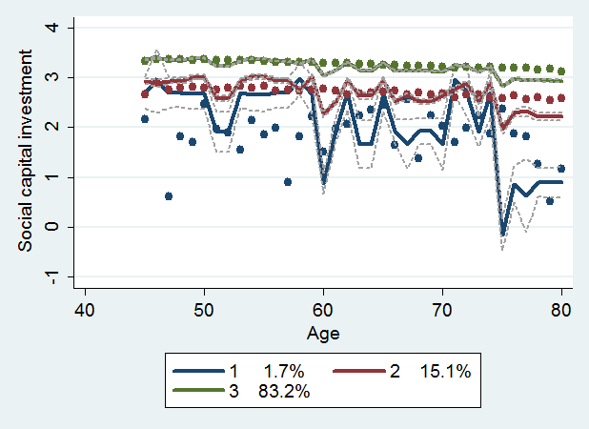

Note: These trajectory paths correspond to the demographic model in table 3. The lower line (blue) is the estimated trajectory path for group 1, the middle line (red) for group 2, and the upper line (green) for group 3. Dashed gray lines show 95% confidence intervals. The lower set of points (blue) are the weighted means of the dependent variable among group 1, the middle set of points (red) among group 2, and the upper set of points (green) among group 3.

*Illustrative models of life satisfaction*

Given the results in previous sections regarding the determinants of individuals’ investment in social capital, we should evaluate the role of social capital in individuals’ life goals and welfare achieved. This can serve to justify the theoretical model used and the analysis performed above. In what follows we will analyze the association between human capital, physical capital, marginal opportunity cost of individuals’ time, social capital stock of each individual, and time to retire/age, on the one hand, and the overall life satisfaction, on the other hand. We will control for individuals’ sex, marital status, and region of residence.

Table 4 presents results of this analysis. In terms of human capital, fixed effects and random effects model only report health satisfaction is significant and positively related as expected while health satisfaction and physical shape in OLS model are significant. But unexpectedly, OLS reports physical shape has a negative influence. Another unexpected report about the education level follows, that is, education level across all the models is not reported to be significant and even shows negative sign in fixed effects model, which seems to imply education is not a significant factor to determine the level of overall life satisfaction.

About physical capital, as expected, every component which consists of physical capital variable – economic satisfaction, assets, and home value – show strongly significant in most cases and report positive relations with life satisfaction.

Note the positive influence of social capital stock on life satisfaction with strong significance and pretty small standard errors. This is one of the key evidence in this study. Household income has a positive significant coefficient across all models as expected. Among variables regarding to time, only age is significant in fixed effects model, which shows negative sign for life satisfaction. In the previous sector, we observed social capital stock/investment among elderly gets lower as they age and the relationship between social capital stock/investment and life satisfaction, which leads to the quite expected result.

Among control variables, women report higher life satisfaction than men. It is understood in the same vein with the result in the previous sector, Regression analysis of investment in social capital*,* that is, this result is perhaps from a lower starting point.Married, separated/divorced, and widowed/emigrated individuals report higher life satisfaction than the baseline group, the never married. Consequently, divorced and widowed individuals appear more content with their life than those never married. Among the ever married group, the married are significantly more content with their life than the separated/divorced, while widowed individuals are surprisingly as content with their life as the married. Finally, among the regional indicators for large cities, small cities and rural areas, only the large city indicator is significant and shows a negative sign. Residents of large cities report less life satisfaction.

The Hausman test once again clearly rejects equality of the sets of coefficients from the models with fixed effects and with random effects. Chi-square statistics are 454 and 423 in the basic model and complete model (with 11 and 13 degrees of freedom), respectively.

Table 4. Regression results of life-satisfaction models

|  |  |  |  |  |  |  |  |
| --- | --- | --- | --- | --- | --- | --- | --- |
| Model vars. | Indicators | OLS | FE | RE | OLS | FE | RE |
| H | Health satisfaction | 0.263*** | 0.197*** | 0.257*** | 0.261*** | 0.191*** | 0.255*** |
|  | (0.007) | (0.009) | (0.007) | (0.007) | (0.010) | (0.007) |
|  | Physical shape | -0.264** | 0.356 | -0.104 | -0.276** | 0.359 | -0.129 |
|  | (0.119) | (0.235) | (0.111) | (0.122) | (0.243) | (0.113) |
|  | Education | 0.103 | -3.106 | 0.079 | 0.098 | -4.116 | 0.074 |
|  | (0.118) | (2.169) | (0.108) | (0.123) | (2.987) | (0.113) |
| K | Economic satisfaction | 0.351*** | 0.291*** | 0.336*** | 0.349*** | 0.289*** | 0.337*** |
|  | (0.007) | (0.009) | (0.006) | (0.007) | (0.009) | (0.007) |
|  | Assets | 0.644*** | 0.393*** | 0.689*** | 0.633*** | 0.463*** | 0.672*** |
|  | (0.089) | (0.136) | (0.078) | (0.099) | (0.166) | (0.084) |
|  | Home value | 0.078** | 0.153** | 0.125*** | 0.051 | 0.121* | 0.091*** |
|  | (0.034) | (0.062) | (0.032) | (0.036) | (0.066) | (0.033) |
| S | Social capital | 0.112*** | 0.086*** | 0.110*** | 0.110*** | 0.082*** | 0.106*** |
|  | (0.008) | (0.014) | (0.008) | (0.009) | (0.015) | (0.008) |
| w | Household income |  |  |  | 0.432*** | 0.345* | 0.456*** |
|  |  |  |  | (0.107) | (0.178) | (0.095) |
| T | Age | 0.016 | -0.463*** | -0.007 | 0.032** | -0.347*** | 0.014 |
|  | (0.012) | (0.058) | (0.011) | (0.014) | (0.079) | (0.013) |
|  | Time to retire |  |  |  | -0.089 | 0.306 | 0.022 |
|  |  |  |  | (0.132) | (0.188) | (0.122) |
| Controls | Female | 0.138** | -- | 0.147*** | 0.140** | -- | 0.142*** |
|  | (0.055) |  | (0.052) | (0.057) |  | (0.053) |
|  | Married | 5.756*** | -1.128 | 6.936*** | 5.408*** | -1.122 | 6.580*** |
|  | (1.164) | (4.301) | (0.976) | (1.157) | (4.281) | (0.962) |
|  | Separated/divorced | 2.355* | -0.851 | 3.465*** | 2.066 | -0.830 | 3.139*** |
|  | (1.363) | (4.770) | (1.160) | (1.365) | (4.748) | (1.152) |
|  | Widowed/emigrated | 5.277*** | -0.174 | 6.580*** | 4.981*** | 0.326 | 6.306*** |
|  | (1.198) | (4.327) | (1.006) | (1.192) | (4.317) | (0.995) |
|  | Large city |  |  |  | -0.829*** | -- | -0.824*** |
|  |  |  |  | (0.267) |  | (0.246) |
|  | Small city |  |  |  | -0.187 | -- | -0.106 |
|  |  |  |  | (0.272) |  | (0.255) |
|  | Constant | 9.353*** | 60.865*** | 9.734*** | 6.752*** | 52.472*** | 6.371*** |
|  | (1.655) | (8.034) | (1.430) | (1.967) | (10.130) | (1.716) |
|  | Within R-squared | 0.525 | 0.216 | 0.210 | 0.527 | 0.208 | 0.203 |
|  | F-test/Wald Chi2 | 1268 | 235.4 | 16,292 | 924.8 | 183.8 | 16,192*** |
|  | Obs. (Clusters) | 23,313 (8,831) | | | 22,437 (8,698) | | |

Notes: Coefficients are significant at *** 1%, ** 5%, * 10%, using standard errors robust to arbitrary heteroskedasticity and autocorrelation.

**Discussion**

Members of the baby-boom generation in Korea have been reported to suffer from having limited social networks, either through own isolation or exclusion by their communities. At the same time, they reveal that social capital is an important component of their life satisfaction. They purposely choose their level of investment and disinvestment in social capital that matches their health-related, economic and other life circumstances. Since the baby-boom and elderly population are becoming a significant social force with a unified voice, as well as human resource that can be tapped, the government cannot afford to ignore their plight. Policy makers should heed the available evidence to improve the living conditions of the elderly, coopt them to participate in socially beneficial activities, and empower them to remain healthy and active without draining public resources.

The importance of social networks in elderly individuals’ lives calls for more care and participation from the public sector. Given that club memberships and frequency of attendance of meetings appear to be the most significant determinants of individuals’ effective stock of social capital, government and non-government organizations should try to promote social and civic engagement of the elderly by providing information, infrastructure or basic services. Unlike the traditional prescription that fiscal aspects come first at affecting the quality of life of people of all ages, the results in this study point to other factors and potential policy interventions as more effective at raising the quality of life of the Korean elderly. Providing meeting places and ensuring good access to physical- and mental- health services may promote elderly people’s engagement and own investment in social capital and networks. These low-resource interventions could bring significant returns in terms of elderly people’s life satisfaction and presence in society.

Another observation is that basic analytical skills and the ability to recall information are critical to individuals’ capacity for social capital investment. When the elderly lose their ability to remember or process information, their willingness and ability to invest in social capital is hindered. This confirms that policymakers in an ageing society should place an emphasis on proper health care, but it also highlights the importance of mental health – including one’s information recall and ability to stay clear of chronic depression – to retaining adequate life satisfaction and self-empowerment among the ageing population. Third, given that the Korean elderly invest more in social capital when they take career development programs and participate in business employment as part-time workers, the government should promote elderly employment. Policy programs could involve public employment or public-private partnerships facilitating part-time utilization of the elderly workforce. Enforcement of antidiscrimination laws should be tightened.

In terms of the analysis performed in this study, several extensions in terms of data sources and methods would be fruitful to undertake. We can use the World Values Survey as an alternative source of socio-economic and demographic data to compare Korea to other East Asian countries. In recent years, panel surveys similar to KLoSA have been introduced in countries worldwide. China has made available several waves of the Chinese Health and Retirement Longitudinal Study (CHARLS), Great Britain has offered the English Longitudinal Study of Ageing (ELSA), and European Union has offered the Survey of Health, Ageing and Retirement in Europe (SHARE). These surveys are comparable in a number of ways, and should be evaluated in tandem. In terms of the focus of enquiry, follow up research should attempt to distinguish better private and public investment in social capital, and evaluate private and social returns to these investments in order to understand the cost-and-benefit implications for policy interventions. Ultimately, relative returns to investments in physical, human and social capital should be estimated, to inform individuals and to provide policy recommendations how public funds should be directed.

**References**

Astone, Nan Marie, Constance A. Nathanson, Robert Schoen, Young J. Kim (1999), Family Demography, Social Theory and Investment in Social Capital, Population and Development Review 25(1):1–31.

[Beugelsdijk](http://www.tandfonline.com/action/doSearch?action=runSearch&type=advanced&searchType=journal&result=true&prevSearch=%2Bauthorsfield%3A(Beugelsdijk%2C+S)), Sjoerd, and [Ton Van Schaik](http://www.tandfonline.com/action/doSearch?action=runSearch&type=advanced&searchType=journal&result=true&prevSearch=%252%3cspan%20onclick=) (2005), *Social capital and growth in European regions: An empirical test*, European Journal of Political Economy 25(2):301–324.

Blundell, Richard (2014), Income Dynamics and Life–Cycle Inequality: Mechanisms and Controversies, Economic Journal 124:289–318.

Cureton, E.E., and R.B. D’Agostino (1983). Factor analysis: An applied approach. Hillsdale, NJ: Erlbaum.

DiPasquale, D., and E. Glaeser (1999), Incentives and Social Capital: Are Homeowners Better Citizens? Journal of Urban Economics 45(2):354–384.

Glaeser, Edward L. (2001), The Formation of Social Capital, Isuma, Canadian Journal of Policy Research 2(1):34–40.

Glaeser, Edward L., David Laibson and Bruce Sacerdote (2002), An Economic Approach to Social Capital, Economic Journal 112:F437–F458.

Glaeser, E., Laibson, D., Scheinkman, J. and Soutter, C. (2000), Measuring trust, Quarterly Journal of Economics, vol. 65(3):811–846.

Hansen, Bruce E. (2009), Lecture Notes on Nonparametrics.

Helliwell, J. F., and R. D. Putnam (1999), Education and Social Capital, NBER Working Paper No. 7121 (Cambridge, MA: National Bureau of Economic Research).

Hofferth, Sandra, Johanne Boisjoly, and Greg J. Duncan (1998), Parents’ extrafamilial resources and children’s school attainment, Sociology of Education 71(3):246–268.

Moulin, Herve (2004), Fair Division and Collective Welfare. Cambridge, Massachusetts: MIT Press.

Nagin, Daniel S. (2005), Group-Based Modeling of Development, Harvard University Press.

Nagin, Daniel S., and Candice L. Odgers (2010), Group-Based Trajectory Modeling in Clinical Research, Annual Review of Clinical Psychology 6:109–138.

Nagin, Daniel S., and Richard E. Tremblay (2001), Analyzing Developmental Trajectories of Distinct but Related Behaviors: A Group-Based Method, Psychological Methods 6(1):18–34.

Parzen, Emanuel (1962), On Estimation of a Probability Density Function and Mode. Annals of Mathematical Statistics 33(3):1065.

Rosenblatt, Murray (1956), Remarks on Some Nonparametric Estimates of a Density Function. Annals of Mathematical Statistics 27(3):832.

Song, Juwon, Soo Young Lee, Chorong Yoon, Rahyel Yoon, Kyung-hwa Song, Byungwon Kim, HyeJung Lee, and Jiyeun Chang (2007), Multiple Imputation for Missing Data in the KLoSA Study, Journal of the Korean Data Analysis Society 9(5):2085–2095.

World Bank (2016), Live Long and Prosper: Aging in East Asia and Pacific. Washington, DC: World Bank.

**Appendix 1. Social Capital Literature**

*Social Capital: Definitions*

Following Jacobs (1961), Loury (1977), Bourdieu (1980), Coleman (1990) and Putnam (1993), social capital as a concept has a long intellectual history in social sciences. An early discourse on social capital was provided by Jane Jacobs (1961) referring to the dense social networks in older, mixed-use urban neighborhoods in American cities as a form of social capital that was “far more responsible for cleanliness, absence of street crime, and other quality-of-life measures than were formal institutional factors like police protection” (p.138). The type of social networks, especially early in life, was found to affect economic achievements of students. The type of social networks was found to affect the benefits that individuals could receive from them. Networks that exhibit ‘closure’ are characterized by reliability and long-term sustainability and appropriability of the stream of benefits (Coleman 1988).

Knack and Keefer (1997) showed that an increase in a measure of country-level trust significantly increases economic growth. LaPorta *et al.* (1997), and Lopez-de-Silanes, Shleifer and Vishny (1997) found that across countries, an increase in a measure of trust increases judicial efficiency and reduces government corruption. Individuals’ social capital was also found to be related to their health. Hence, people have a purpose to strive to increase their stock of social capital. “Networks are not merely the result of historical accident, they come about as individuals spend time and energy to connect with others” (DiPasquale and Glaeser 1999).

Social capital can be a relevant concept at the micro and macro levels. At the macro level, social capital is an aggregate variable including institutions such as government, the rule of law, civil: the norms and networks of a particular community and political liberties, etc. Jacobs (1961) defines social capital as neighborhood networks. Putnam (1995) also viewed social capital as a feature of social groups, the “features of social life – networks, norms, and trust – that enable participants to act together more effectively to pursue shared objectives” (p.664–665). Putnam (1993) identified the importance of social capital in various domains at the aggregate level. Local governance can be more efficient under stronger civic engagement. At the micro level, social capital can include a person’s social characteristics, including social skills, charisma, status and access to networks.

Social capital of a society is a function of various types of social engagement in the society, and is an aggregation of the stocks of social capital of all individuals in that society (Glaeser). There is an older definition of social capital that is individual-based, dependent on an individual’s social resources. Individual social as the set of social attributes possessed by and individual – including charisma, contacts and linguistic skill – that increase the returns to that individual in his dealings with others. Such a definition is a precise analogue of the economic concepts of human and physical capital, and it is individual-based so we can think about the process by which an individual invests in social capital (James 1904).

*Korean evidence*

Korea was estimated to have the highest growth rate of social capital among OECD countries during 1970-1985, and second highest during 1985-1995, after which the rate tapered off to intermediate values just above the median. Averaged across all years 1970-2005, Korea still had by far the highest growth rate of social capital of 8 percent (Perez Garcia, Serrano Martinez and Fernandez de Guevara Radoselovics 2008). While this high accumulation of social capital is likely due to a variety of reasons, some contributing factors that have been identified in theoretical literature could be Korea’s ethnic and cultural homogeneity, which facilitates group membership (Alesina and LaFerrara 2000), and low mobility and high homeownership, which encourage investment in social capital that generates community benefits (DiPasquale and Glaeser 1999). Low preexisting stock of social capital may have contributed too.

Jang (2011) investigated the effects of social capital on the economic satisfaction of retirees in Korea. The data from the first wave of Korean Longitudinal Study of Aging were used. Jang (2011) defined social capital as cognitive social capital (trust and reciprocity) and structural social capital (emotional and economic familial support, and a well-developed social network). The major findings were as follows. First, after controlling for gender, age, region, housing tenure, and personal income, the social capital of retirees, including cognitive social capital and structural social capital contributes to increases in their economic well-being. Second, the degree of effect social capital has on well-being varied by gender and age.

Seo, Jiwon, (2005) studied about the determinants of the expected demand for elderly care by government. The data from the 1st wave of Klosa aged over 45 were used. In this study, social capital was perceived in terms of informal (regular financial support from children, the number of times that meet with friends and any carer in the future) and formal network (participating to the reunion, social clubs and political party). Seo found that, first, human capital, social capital, and socioeconomic variables influenced on the expected demand for elderly care by government, controlling the expectations of future life and society. Second the effects of determinants on the expected demand for elderly care by government varied by the level of human capital, social capital, and socioeconomic variables.

Seo, Jiwon (2013) also studied about social capital with other subject. The purpose of this study is to analyze the age effect of social capital by comparing middle aged and the elderly, as well as to investigate the independent effects of social capital on their subjective economic well-being, respectively. The two concepts of “trust” and “social network” were used to measure the level of social capital. Comparisons between the age groups were made regarding the relationships between social capital and economic well- being of four age groups, including younger middle-aged, older middle-aged, younger elderly, and older elderly. This study loosely follows the above definitions. The analysis is limited to social capital at the level of individuals.

Table A1. Definitions of Social Capital

|  |  |
| --- | --- |
| Bourdieu (1985) | “the aggregate of the actual or potential resources which are linked to possession of a durable network of more or less institutionalized relationships of mutual acquaintance or recognition” (248). |
|  | “made up of social obligations (‘connections’), which is convertible, in certain conditions, into economic capital and may be institutionalized in the form of a title of nobility” (243). |
| Baker (1990) | “a resource that actors derive from specific social structures and then use to pursue their interests; it is created by changes in the relationship among actors” (619). |
| Coleman (1990) | “Social capital is defined by its function. It is not a single entity, but a variety of different entities having two characteristics in common: They all consist of some aspect of social structure, and they facilitate certain actions of individuals who are within the structure” (302). |
| Boxman, De Graaf & Flap (1991) | “the number of people who can be expected to provide support and the resources those & Flap people have at their disposal” (52). |
| Bourdieu & Wacquant (1992) | “the sum of the resources, actual or virtual, that accrue to an individual or a group by virtue of possessing a durable network of more or less institutionalized relationships of mutual acquaintance and recognition” (119). |
| Burt (1992) | “friends, colleagues, and more general contacts through whom you receive opportunities to use your financial and human capital” (9). |
| Loury (1992) | “naturally occurring social relationships among persons which promote or assist the acquisition of skills and traits valued in the marketplace... an asset which may be as significant as financial bequests in accounting for the maintenance of inequality in our society” (100). |
| Portes & Sensenbrenner (1993) | “those expectations for action within a collectivity that affect the economic goals and goal- Sensenbrenner seeking behavior of its members, even if these expectations are not oriented toward the economic sphere” (1323) |
| Putnam (1995) | “features of social organization such as networks, norms, and social trust that facilitate coordination and cooperation for mutual benefit” (67). |
| Fukuyama (1995, 1997) | “the ability of people to work together for common purposes in groups and organizations” (1995:10) |
|  | “Social capital can be defined simply as the existence of a certain set of informal values or norms shared among members of a group that permit cooperation among them” (1997:169) |
| Belliveau, O’Reilly & Wade (1996) | “an individual’s personal network and elite institutional affiliations” (1572). |
| Brehm & Rahn (1997) | “the web of cooperative relationships between citizens that facilitate resolution of collective action problems” (999). |
| Pennar (1997) | “the web of social relationships that influences individual behavior and thereby affects economic growth” (154). |
| Glaeser (2001) | “set of social resources of a community that increases the welfare of that community” including “norms, networks and other related forms of social connection” (4). |

**Appendix 2. Summary Statistics**

Table A2. Definition of indicators used in principal component analysis

|  |  |  |  |
| --- | --- | --- | --- |
| Name | Definition, Obs. if <34,348 (Units) | Avg. (St.Dev.)i | Min–Max |
| Contacts | Frequency meet close friends (days/year) | 3.662 (1.677) | 0–5.207 |
| Socnetwork1 | 1 if participate in religious group | .219 (.413) | 0–1 |
| Socnetwork2 | 1 if participate in friendship | .571 (.495) | 0–1 |
| Socnetwork3 | 1 if participate in leisure/culture/sports group | .043 (.204) | 0–1 |
| Socnetwork4 | 1 if participate in alumni associations | .168 (.374) | 0–1 |
| Socnetwork5 | 1 if participate in volunteer causes | .017 (.128) | 0–1 |
| Socnetwork6 | 1 if participate in political party/interest group | .004 (.063) | 0–1 |
| Socnetwork7 | 1 if participate in other groups | .0003 (.017) | 0–1 |
| Socnetwork8 | 1 if no participation in any groups | .261 (.419) | 0–1 |
| Numberofsc1 | How often participate in religious group (days/year) | .794 (1.60) | 0–5.207 |
| Numberofsc2 | How often participate in friendship activities (days/year) | 1.678 (1.686) | 0–5.207 |
| Numberofsc3 | How often participate in leisure/culture/sports groups (days/year) | .164 (.817) | 0–5.207 |
| Numberofsc4 | How often participate in alumni assocs. (days/year) | .271 (.752) | 0–5.207 |
| Numberofsc5 | How often participate in volunteering (days/year) | .049 (.418) | 0–5.207 |
| Numberofsc6 | How often participate in political party/interest group (days/year) | .009 (.171) | 0–5.207 |
| Numberofsc7 | How often participate in other groups (days/year) | .001 (.0613) | 0–5.207 |
| meetwithfamily | How often meet own children (days/year) | 33.111 (48.858) | 0–182.5 |
| meetbyphone | How often contact his/her children by phone, letter or e-mail (days/year) | 74.812 (59.497) | 0–182.5 |
| Married1 | 1 = married; 0 = not | .770 (.421) | 0–1 |
| Married2 | 1 = divorced or live separately with spouse; 0 = otherwise | .027 (.161) | 0–1 |
| Married3 | 1 = spouse is dead or in North Korea; 0 = otherwise | .195 (.396) | 0–1 |
| Capitallend | The amount of money the person lent (104 won) | .047 (.601) | 0–11.705 |
| Capitalborrow | Debt borrowed personally (104 won) | 56.967 (789.056) | 0–11.944 |
| Suretylend | Amount of money the person stands security for debt of other people | .049 (.623) | 0–11.551 |
| Feelinglonely | Feeling lonely in past week (0.5=on <1 day; 1.5 = 1–2 days; 3.5 = 3–4 days; 6 = 5+ days) | 1.109 (1.130) | 0-6 |
| Trustgov | Possibility that government supports for your golden years (10-good) | 37.434 (22.578) | 0–100 |
| Trustcomm | do you see your standard of living go down in the future? (0-good) | 46.967 (23.080) | 0–100 |
| Socactfreq | Frequency of social-activity participation (count/year) | .274 (1.209) | 0–40 |
| Expenonsocact | Expenditure on social activity, 1,857 obs. (103 won) | 7.657 (16.798) | 0–282.273 |
| Friendsfreq | Frequency of meeting friends (count/year) | .474 (3.658) | 0–150 |
| Expenonfriends | Expenditure on meeting friends, 770 obs. (103 won) | 5.369 (8.836) | 0–100 |
| CDPfreq | Frequency of career development program, 24,091 obs. (count/ a year) | .155 (2.820) | 0–5.298 |
| ExpenonCDP | Expenditure on career development programs, 224 observations (103 won) | 5.213 (10.499) | 0–68 |
| Volunteerfreq | Frequency of volunteering (count/year) | .510 (5.274) | 0–200 |

i Evaluated in an unbalanced panel of all the available observations for which dependent variable is non-missing – 34,348 observations for 10,254 respondents in 4 biannual waves. Monetary variables are deflated to year-2010 won using consumer price index (CPI: 2006: 88.070; 2008: 94.523; 2012: 106.280).

ii Missing values are interpolated using predicted values from cross-individual weighted average.

iii Provinces: Seoul, Busan, Daegu, Incheon, Gwangju, Daejeon, Ulsan, Gyeonggi, Kangwon, Chungbuk, Chungnam, Jeonbuk, Jeonnam, Gyeongbuk, Gyeongnam.

Data sources: KLoSA; KOSIS.

Table A3. Definition of explanatory variables used in Estimation

|  |  |  |  |
| --- | --- | --- | --- |
| Name | Definition, Obs. if <34,348 (Units) | Avg. (St.Dev.)i | Min–Max |
| Assets | Total household assets, 24,150 obs. (104 won) | 22,219.370 (32,518.780) | 0–683,220 |
| Age | Western/solar age (years) | 64.133 (10.920) | 45–107 |
| Badhealth | Subjective health (1 = best; 5 = worst index) | 2.998 (.947) | 1–5 |
| Nohealthlimit | How much the person has a limitation for activity because of health status (1 = very much; 4 = not at all) | 2.751 (.864) | 1–4 |
| Baddiagnosis | Doctor’s diagnosis of an physical obstacle, 32,583 obs. (1 = bad health) | .028 (.165) | 0–1 |
| Regworkout | Frequency of regular exercise/week, 34,347 obs. (count) | 1.647 (2.586) | 0–4.174 |
| Edu | The highest level of schooling, 34,339 obs. (1 = up to elementary; 4 = BA degree+) | 2.005 (1.067) | 1–4 |
| Income | Household total yearly income, 33,202 obs. (104 won) | 2,425.091 (2,642.322) | 0–96,653.72 |
| Bigcity | 1 if the person lives in urban, 0 otherwise | .434 (.496) | 0–1 |
| Smallcity | 1 if the person lives in small city, 0 otherwise | .321 (.467) | 0–1 |
| Patience | The amount one would like to spend on things other than leisure activities (i.e., donation, saving) if given 10 mil. Won ([1000-leisure]/1000; %/100). | .840 (.310) | 0–1 |
| Depress | Feeling depressed, 24,094 obs. (1=depressed, 0=not) | .068 (.252) | 0–1 |
| Gloomy | How often the person feels gloomy, 34,104 obs. (1=a little bit; 2=sometimes; 3=often; 4=always) | 1.460 (.725) | 1–4 |
| Memory | Memorization test, 33,014 obs. (3=having memorized 3 words; 2=2 words; 1=1 word; 0=no words) | 2.623 (.757) | 0–3 |
| Analyticskills | Test of concentration and basic calculation, 33,017 obs. (1=correct; 0=wrong) | .859 (.348) | 0–1 |
| Healthsatisf | Health status satisfaction, 34,337 obs. (100=happiest; 0=unhappiest) | 55.217 (22.589) | 0–100 |
| Econsatisf | Satisfaction with economic situation, 34,336 obs. (100=happiest; 0=unhappiest) | 50.429 (22.511) | 0–100 |
| Overallqual | Overall quality of life, 34,333 obs. (100=happiest; 0=unhappiest) | 60.366 (19.425) | 0–100 |
| Physshape | Obesity, 33,448 obs. (1=normal weight; 2=slightly over/underweight; 3=more overweight; 4=most overweight) | 3.197 (.8214) | 1–4 |
| Vehicle | Car owenrship, 34,341 obs. (1=yes) | .220 (.414) | 0–1 |
| Travelfreq | Frequency of travel, 24,091 obs. (count/year) | 1.002 (2.488) | 0–100 |
| Expenontravel | Expenditure on travel, 9,119 obs. (103 won) | 54.966 (114.086) | 0–2,000 |
| Church_pciii | Churches per person 45+ years old in province (count/capita) | 3.306 (1.087) | 1.406–5.110 |
| PublicHealth_pc | Public health care facilities per capita in province (count/capita) | 22.071 (23.149) | .729–72.851 |
| Clinic_pc | Clinics per capita for elderly in province (count/capita) | 4.728 (.978) | 3.505–11.224 |
| Eldfac_pc | Elderly facilities per capita (count/capita) | 1.782 (.910) | .320–4.148 |
| Popgt45_pc | Population 45+ years old per capita in province (count/capita) | .343 (.047) | .256–.454 |
| Employedd | Employment status (1=working; 0=non-working) | .406 (.491) | 0–1 |
| Biz empl | Doing own business or working with family (1 = yes; 0 = no). | .222 (.415) | 0–1 |
| Time to retire | Planned age for retirement – current age, 25,782 obs. (years) | 20.928 (11.667) | 0–3.807 |

i Evaluated in an unbalanced panel of all the available observations for which dependent variable is non-missing – 34,348 observations for 10,254 respondents in 4 biannual waves. Monetary variables are deflated to year-2010 won using consumer price index (CPI: 2006: 88.070; 2008: 94.523; 2012: 106.280).

ii Missing values are interpolated using predicted values from cross-individual weighted average.

iii Provinces: Seoul, Busan, Daegu, Incheon, Gwangju, Daejeon, Ulsan, Gyeonggi, Kangwon, Chungbuk, Chungnam, Jeonbuk, Jeonnam, Gyungbuk, Gyungnam.

Data sources: KLoSA; KOSIS.

Figure A1. Distribution of social capital stock index, by demographic group

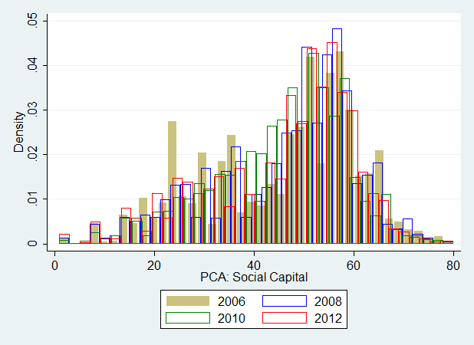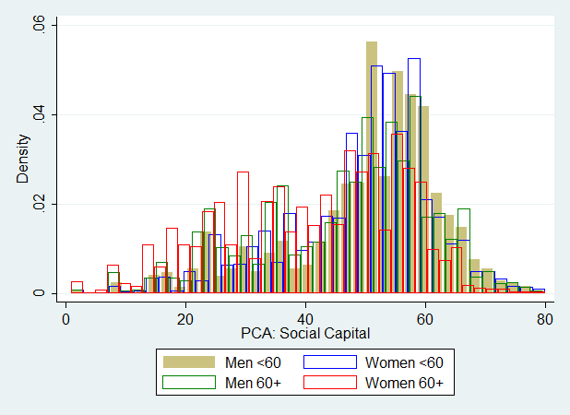

i. By year ii. By age and sex

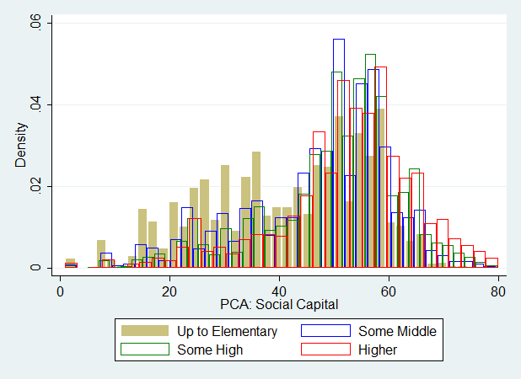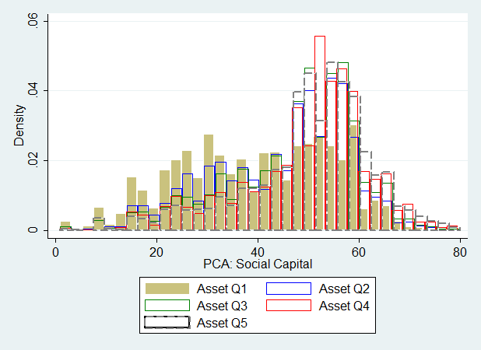

iii. By education iv. By asset quintile

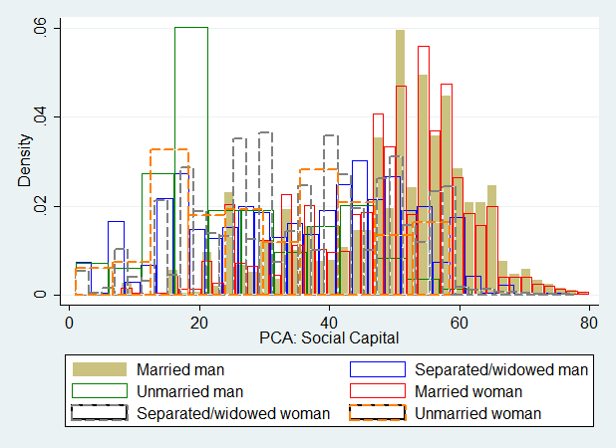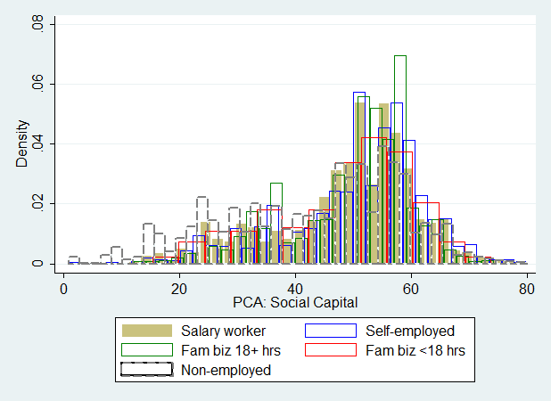

v. By marital status and sex vi. By employment status

Note: Distributions are truncated at 60 to show differences in densities more clearly.

Figure A2. Distribution of social capital investment index, by demographic group

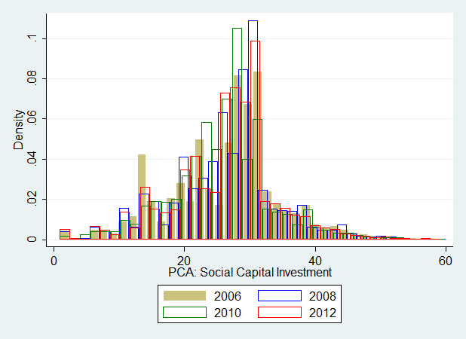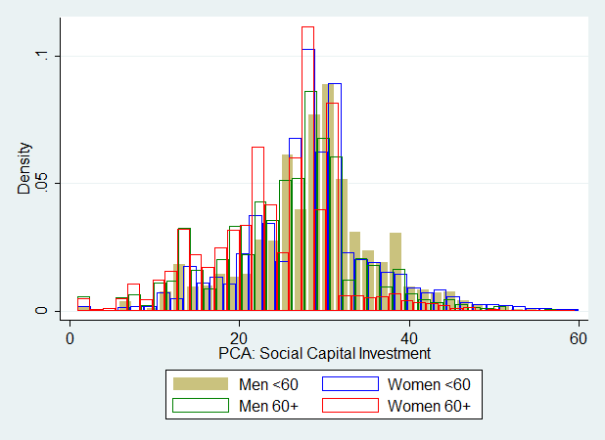

i. By year ii. By age and sex

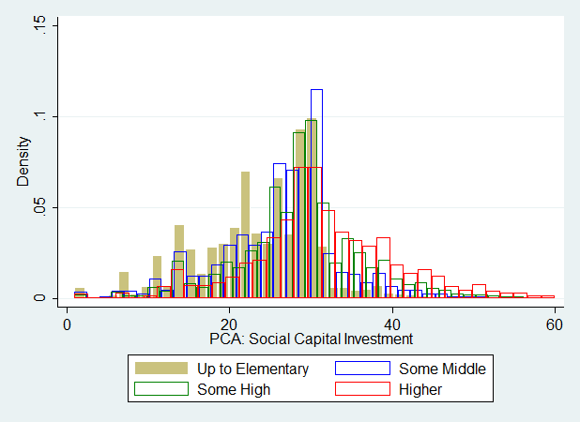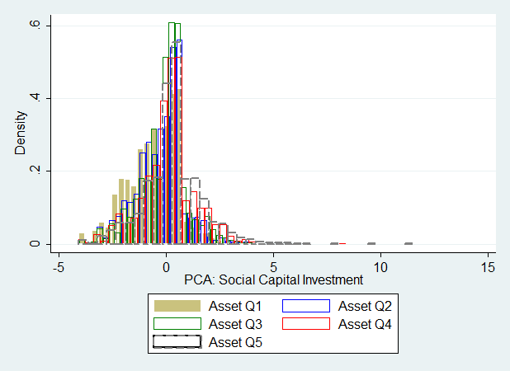

iii. By education iv. By asset quintile

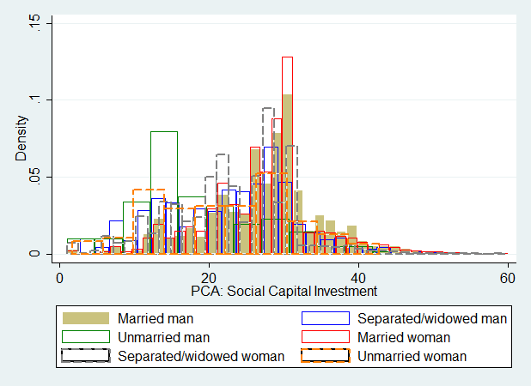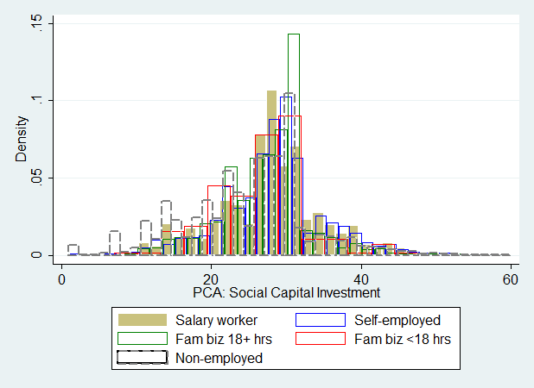

v. By marital status and sex vi. By employment status

Note: Distributions are truncated at 33 (20 in panel v.) to show differences in densities more clearly.

Figure A3. Distribution of social capital stock vs. investment

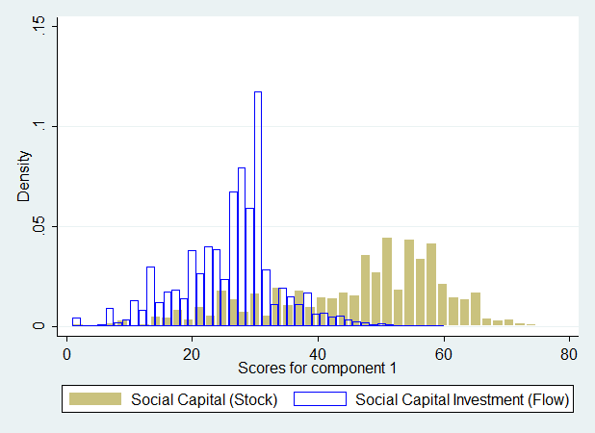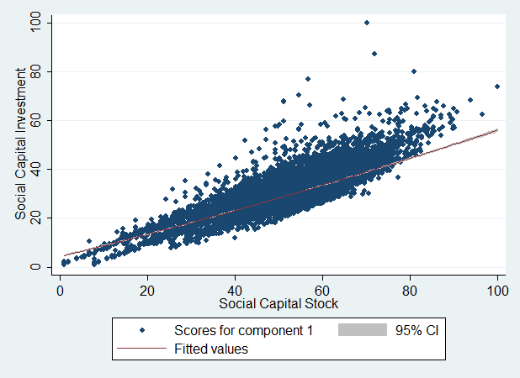

i. Histogram ii. Scatterplot and quadratic fitted line

Note: Distributions in panel i. are truncated at 50 to show differences in densities more clearly.

Table A4. Joint density of quintiles of *S* and *K*, 2006–2012

|  |  |  |  |  |  |  |
| --- | --- | --- | --- | --- | --- | --- |
| *S* \ *K* | Q1 | Q2 | Q3 | Q4 | Q5 | Missing |
| Q1 | 2.73 | 3.04 | 0.59 | 1.87 | 2.13 | --a |
|  | (7.57) | (4.22) | (2.99) | (2.66) | (1.69) | (0.95) |
|  | [8.67] | [3.71] | [2.83] | [2.40] | [1.78] | [0.62] |
|  | {8.05} | {4.49} | {3.64} | {2.37} | {1.92} | {0.51} |
| Q2 | 5.07 | 4.25 | 3.46 | 4.58 | 2.74 | -- |
|  | (4.56) | (4.27) | (3.16) | (3.66) | (3.76) | (0.76) |
|  | [4.96] | [3.55] | [3.94] | [3.87] | [3.21] | [0.63] |
|  | {4.17} | {4.49} | {3.76} | {3.53} | {4.12} | {0.37} |
| Q3 | 4.40 | 6.17 | 4.60 | 3.90 | 5.12 | -- |
|  | (3.01) | (4.22) | (4.03) | (4.28) | (3.75) | (0.46) |
|  | [3.33] | [4.17] | [4.41] | [5.08] | [3.91] | [0.74] |
|  | {2.80} | {3.41} | {4.17} | {4.22} | {3.73} | {0.28} |
| Q4 | 5.04 | 5.82 | 2.91 | 5.10 | 4.21 | -- |
|  | (2.81) | (4.51) | (4.18) | (3.76) | (3.99) | (0.75) |
|  | [2.44] | [3.64] | [3.92] | [4.17] | [4.54] | [0.64] |
|  | {2.66} | {4.41} | {4.27} | {4.92} | {4.69} | {0.35} |
| Q5 | 3.57 | 5.69 | 3.05 | 4.90 | 5.08 | -- |
|  | (1.71) | (3.63) | (3.63) | (4.88) | (5.27) | (0.87) |
|  | [2.01] | [2.76] | [3.90] | [4.42] | [5.01] | [0.74] |
|  | {1.93} | {2.94} | {3.81} | {4.56} | {4.98} | {0.47} |

Note: Year 2006 (2008) [2010] {2012}. Observations are weighted by their cross-sectional weights.

a In 2006, missing values for assets *K* are omitted from the counts, due to their large number.

Table A5. Joint density of quintiles of *I* and *w*, 2006–2012

|  |  |  |  |  |  |  |
| --- | --- | --- | --- | --- | --- | --- |
| *I* \ *w* | Q1 | Q2 | Q3 | Q4 | Q5 | Missing |
| Q1 | 4.66 | 5.12 | 3.75 | 2.12 | 1.47 | 2.91 |
|  | (7.38) | (4.76) | (3.79) | (1.99) | (1.65) | (0.44) |
|  | [7.62] | [4.64] | [4.07] | [2.06] | [1.55] | [0.12] |
|  | {7.97} | {3.85} | {3.84} | {2.64} | {1.44} | {0.28} |
| Q2 | 5.06 | 3.94 | 4.04 | 3.19 | 2.18 | 1.56 |
|  | (4.35) | (4.65) | (4.94) | (2.74) | (3.19) | (0.38) |
|  | [5.19] | [4.45] | [4.91] | [2.62] | [2.88] | [0.13] |
|  | {4.81} | {3.79} | {5.21} | {3.48} | {3.01} | {0.09} |
| Q3 | 4.03 | 3.15 | 3.98 | 3.90 | 3.72 | 1.22 |
|  | (3.39) | (4.56) | (5.61) | (2.62) | (3.16) | (0.43) |
|  | [3.16] | [4.17] | [5.59] | [3.00] | [3.93] | [0.06] |
|  | {4.35} | {4.09} | {5.02} | {4.14} | {3.60} | {0.08} |
| Q4 | 3.77 | 3.63 | 4.19 | 4.05 | 3.61 | 1.07 |
|  | (3.34) | (4.38) | (5.15) | (2.73) | (3.99) | (0.43) |
|  | [2.56] | [4.66] | [5.30] | [3.22] | [4.26] | [0.12] |
|  | {3.60} | {3.50} | {4.45} | {3.43} | {3.30} | {0.05} |
| Q5 | 2.25 | 2.29 | 2.70 | 4.05 | 7.17 | 1.22 |
|  | (1.33) | (2.87) | (4.39) | (4.24) | (6.95) | (0.15) |
|  | [1.37] | [3.05] | [4.48] | [3.45] | [7.27] | [0.11] |
|  | {1.63} | {2.30} | {4.30} | {4.57} | {7.10} | {0.09} |

Note: Year 2006 (2008) [2010] {2012}. Observations are weighted by their cross-sectional weights.

Figure A4. Individuals’ social capital, 2006 versus 2012

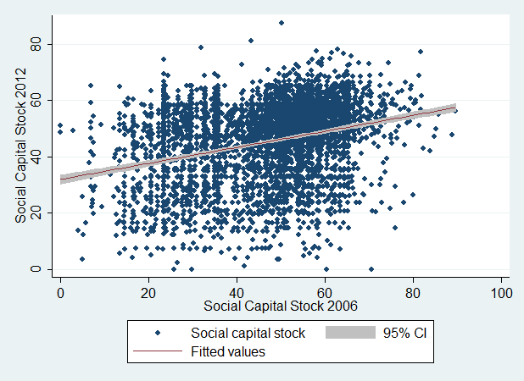

Note: Individual-level observations are collapsed into social-capital percentile clusters (10,000 clusters for each percentile of 2006 S × percentile of 2012 S) for clarity of presentation.

Figure A5. Histograms of log valued variables and social capital stock/investment



i. Log valued age ii. Log valued real total household annual income



iii. Log valued real assets iv. Stock of social capital in 2006



v. Stock of social capital in 2012 vi. Investment in social capital in 2006



vii. Investment in social capital in 2012

Note: Distribution in panel *i.* is truncated to show differences in densities more clearly.

**Appendix References**

Coleman, J.S. (1988), Social capital in the creation of human capital, American journal of sociology.

Jacobs, Jane (1961), *The Death and Life of Great American Cities*.

James, H. (1904), The Golden Bowl (New York: C. Scribner’s Sons).

Jang, Younju (2011), The Effects of Social Capital on the Economic Satisfaction of Korean Retirees, Dept. of Consumer Science, Seoul National University.

Knack, S., and P. Keefer (1997), Does Social Capital Have an Economic Payoff? A Cross-Country Investigation, Quarterly Journal of Economics 112(4): 1251-1288.

Putnam (1993), The Prosperous Community: Social Capital and Public Life. The American Prospect 13(1): 35-42.

Putnam, Robert D. (1995) Bowling Alone: America’s Declining Social Capital, Journal of Democracy 6(1): 65-78.

Putnam, R. (2000), Bowling Alone: The Collapse and Revival of American Community, New York: Simon and Schuster.

Seo, Jiwon (2005), The Determinats of the Expected Demand for Elderly Care by Government, Working paper, Dept. of Home Economics, Korea National Open University.

Seo, Jiwon (2013), Age Effects of Social Capital on the Economic Well-Being in Korea.

Jones, B. L., D. S. Nagin, and K. Roeder (2001) A SAS procedure based on mixture models for estimating developmental trajectories. Sociological Methods & Research 29:374-393.

Jones, B. L. and D. S. Nagin (2007) Advances in group-based trajectory modeling and an SAS procedure for estimating them. Sociological Methods & Research 35:542–571.

Jones, Bobby L., and Daniel S. Nagin (2012) A Stata Plugin for Estimating Group-Based Trajectory Models, Heinz College Research working paper, Carnegie Mellon University, 5-21-2012.

1. In Korea, unlike in the US or recently in the EU, cross-region mobility is not very common, particularly among the elderly population, and is thus ignored in the following empirical analysis.
2. One public-policy problem is of course that this private-rents maximization externalizes the benefits of one’s social-capital investment bestowed on other community members. Private investment falls short of socially efficient levels which, aggregated across many social-capital investors and beneficiaries, is expected to yield substantial welfare losses.
3. To the extent that $R\left(∙\right)$ and $C\left(∙\right)$ have components that depend on external variables or that are empirically inseparable from other components, we may also evaluate the overall effect of $R$ and $C$ on : , .
4. =1, 2, …, n.
5. As an alternative measure of *net* social capital accumulation, we could evaluate the change in the stock of social capital over time, $∆S_{it}$. However, this is thought to be problematic, because gross investment cannot be easily separated from depreciation and loss, generating measurement error.
6. On the other hand, schooling has been identified as a production process for not only human capital but also social capital (Helliwell and Putnam 1999).
7. Through stratified sampling and cross-sectional population weights, the sample is representative of 15,864,949 baby-boomers in 2006, 15,422,837 in 2008, 14,013,867 in 2010 and 14,621,343 in 2012. Accounting for attrition and addition of new households, using longitudinal weights, the sample is representative of 15,864,949 baby-boomers in 2006, 15,980,420 in 2008, 16,027,325 in 2010 and 16,697,158 in 2012.
8. The second principal component would explain an additional 12.5% of the variance, or 44% less than the first component, and would have an eigenvalue of 1.13. These statistics suggest that the first component is clearly more influential in driving the index of social capital than other components, but it is responsible for a limited fraction of variation in overall social capital. Allowing for multiple dimension of social capital would be a fruitful extension of this work.
9. The following indicators did not contribute adequately to the index of social capital investment, and were thus omitted: How frequently you meet or contact your children; Expectations over your future economic status, interpreted as trust in market institutions.
10. The second principal component would explain an additional 13.6 9% of the variance, or 35% less than the first component, and would have an eigenvalue of 1.09.
11. Kernel density estimation using the rule-of-thumb bandwidth may be a good start but may not represent the most robust method. Obtaining asymptotically optimal bandwidth via asymptotic mean integrated squared error would be more robust. In this paper, however, we restrict ourselves to providing a basic estimate of the joint probability density function. Hence, we impose the restrictive assumption of multivariate normality for all variables of interest.
12. Married elderly are those who currently live with their spouses. More detailed classification of marital status is provided in appendix 2.
13. To perform this test, the models are adjusted to use the same sets of controls (time-constant sex and city indicators are removed), probability weights are removed from models with fixed effects, and ordinary standard errors uncorrected for heteroskedasticity and autocorrelation are used. To make it harder to reject the hypothesis of equality of coefficients, and to avoid producing a non-positive-definite-differenced covariance matrix,

    covariance matrices are based on the estimated error variance from the same model, the efficient random-effects model. Alternative versions of the test, using two sets of error variances, or variances from the fixed-effects model yield even higher test statistics.
14. , where *L* is the model likelihood, *n* is sample size and *k* is the number of estimable parameters (Nagin and Trembley 2001). Model likelihood is not discounted sufficiently for degrees-of-freedom losses. BIC is thought to be a consistent criterion as long as the latent true economic process is among the specifications considered, and typically gives rise to more parsimonious models, while AIC is regarded as an asymptotically efficient model-selection criterion with superior properties in large samples. Given the complex nature of the question at hand, BIC is thought to select a more practical model and yield smoother trajectories than the AIC.